Class XII Chemistry
Practice Papers NCERT BOOK PART 1

CHEMISTRY PRACTICE PAPER BOOK 1 SET -01
Class: XII
S.No | Chapter | MCQ | A/R | VSA I | SA I | Case Based | LA | Total
S.No | Chapter | 1 Marks | 1  Marks | 2 Marks | 3 Marks | 4  Marks | 5  Marks
1 | Solutions | 1(1) |  | 2(1) |  | 4(1) |  | 7(3)
2 | Electrochemistry | 1(1) |  | 2(1) | 6(2) |  |  | 9(4)
3 | Chemical Kinetics | 2(2) |  |  |  |  | 5(1) | 7(3)
4 | d -and f -Block Elements | 1(1) | 1(1) |  |  |  | 5(1) | 7(3)
5 | Coordination Compounds | 2(2) |  | 2(1) | 3(1) |  |  | 7(4)
 | Total | 7(7) | 1(1) | 6(3) | 9(3) | 4(1) | 10(2) | 37(17)
Note: - Marks are outside of bracket and number of questions in bracket

Set 01
Practice Paper BOOK 1 (2023-24)
MM:37 CHEMISTRY THEORY (043) Time: 1 ½ hours
SECTION A
The following questions are multiple-choice questions with one correct answer. Each question carries 1 mark. There is no internal choice in this section.
1 | For non-electrolyte solute the value of Van’t Hoff factor is  - 0 ( b) 1 (c) >1 (d) <1 | 1
2 | Charge carried by 1 mole of electrons is  (a) 6.023 × 10²³ coulomb (b) 9.65 × 10⁴ coulomb  (c) 1.6 × 10^{–19} coulomb (d) 6.28 × 10¹⁹ coulomb | 1
3 | The difference between the electrode potentials of two electrodes when no current is drawn through the cell is called  (a) Cell potential (b) Cell emf (c) Potential difference (d) Cell voltage | 1
4 | In the reaction, A + 2B 6C + 2D, if the initial rate – d [A]/dt at t = 0 is 2.6 × 10^{–2} M sec^{–1}, what will be the value of – d [B]/dt at t = 0?  (a) 8.5 × 10^{–2} M sec^{–1} (b)2.5 × 10^{–2} M sec^{–1}  (c) 5.2 × 10^{–2} M sec^{–1} (d)7.5 × 10^{–2} M sec^{–1} | 1
6 | The magnetic moment is associated with its spin angular momentum and orbital angular momentum. Spin only magnetic moment value of Cr³⁺ ion is  (a) 2.87 B.M. (b) 3.87 B.M. (c) 3.47 B.M (d) 3.57 B.M | 1
7 | The compounds [Co(SO₄)(NH₃)₅]Br and [Co(SO₄)(NH₃)₅]Cl represents  (a) Linkage isomerism (b) No isomerism  (c) Ionisation isomerism (d) Coordination isomerism | 1
8 | The formula of the complex tris(ethylenediamine)cobalt(III) sulphate is  (a)[Co(en)₃]SO₄ (b)[Co(en)₃ SO₄]  (c)[Co(en)₃]₂(SO₄)₃ (d)[Co(en)₃](SO₄)₃ | 1
In the Following questions a statement of Assertion(A) is followed by a statement of Reason(R). Select the most appropriate answer from the options given below:
(a) Both A and R are true and R is the correct explanation of A
(b) Both A and R are true but R is not the correct explanation of A.
(c) A is true but R is false.
(d) A is false but R is true.
8 | Assertion(A): Zn, Cd, Hg and Cn are not regarded as transition metals.  Reason(R): These elements do not belong to d-block of periodic table.  . | 1

SECTION B
This section contains 5 questions with internal choice in onequestion. The following questions are very short answer type and carry 2 marks each.
9 | Calculate the emf of the cell in which the following reaction takes place:  Ni(s) + 2Ag⁺ (0.002 M)------→ Ni²⁺ (0.160 M) + 2Ag(s)  [Given that Eº cell = 1.05 V, log 2 = 0.301] | 2
10 | Write the chemistry of recharging the lead storage battery, highlighting all the materials that are involved during recharging. | 2
11 | A metal ion M⁺ having d⁴ valence electronic configuration combines with three bidentate ligands to form a complex compound. Assuming Δ₀> P:  (i)Name the type orbital splitting during this complex formation.  (ii) Write the electronic configuration of the valence electrons of the metal M⁺ ion in terms of t_{2g} and e_{g}. | 2

SECTION C
This section contains 7 questions with internal choices in one question. The following questions are short answer types and carry 3 marks each.
12 | The chemistry of corrosion of iron is essentially an electrochemical phenomenon. Explain the reactions occurring during the corrosion of iron in the atmosphere. | 3
13 | The limiting molar conductivity of sodium acetate, sodium chloride and hydrochloric acid are 83, 127 and 426 mho${ cm}^{2}{mol}^{-1}$ at ${250}^{∘}C$ respectively. Calculate the limiting molar conductivity of acetic acid solution. | 3
14 | CoSO₄Cl.5NH₃ exists in two isomeric forms ‘A’ and ‘B’. Isomer ‘A’ reacts with AgNO₃ to give white precipitate, but does not react with BaCl₂. Isomer ‘B’gives white precipitate with BaCl₂ but does not react with AgNO₃. Answer the following questions.  (i) Identify ‘A’ and ‘B’ and write their structural formulas.  (ii) Name the type of isomerism involved.  (iii) Give the IUPAC name of ‘A’ and ‘B’. | 3

SECTION D
The following questions are case-based questions. Each question has an internal choice and carries 4 (1+1+2) marks each. Read the passage carefully and answer the questions that follow.
15 | Read the passage given below and answer the following questions:  The solubility of gases increases with increase of pressure. William Henry made a systematic investigation of the solubility of a gas in a liquid. According to Henry's law "the mass of a gas dissolved per unit volume of the solvent at constant temperature is directly proportional to the pressure of the gas in equilibrium with the solution".  Dalton during the same period also concluded independently that the solubility of a gas in a liquid solution depends upon the partial pressure of the gas. If we use the mole fraction of gas in the solution as a measure of its solubility, then Henry's law can be modified as "the partial pressure of the gas in the vapour phase is directly proportional to the mole fraction of the gas in the solution':  (i) Why the aquatic animals feel more comfortable in cold water.  (ii) How solubility of gas in liquid varies with increasing temperature.  (iii)Write any two applications of henry law.  OR  (iii) State Henry’s law for gas in liquid solution. Write the mathematical expression of this law. | 4

SECTION E
The following questions are long answer type and carry 5 marks each. Two questions have an internal choice.
16 | Attempt any five of the following-  (a) Why enthalpy of atomisation of transition metals are quite high.  (b) There is a close similarity in physical and chemical properties of the 4d and 5d series of the transition elements, much more than expected on the basis of usual family relationship. Explain.  (c)Why the members in the actinoid series exhibit larger number of oxidation states than the corresponding members in the lanthanoid series.  (d)${Cu}^{2+}$ is stable in aqueous solution inspite of having ${3d}^{9}$ configuration. Why?  (e) The E° values of Mn and Zn is more negative. Give reason.  (f) The transition metals are generally paramagnetic in nature why?  (g) Scandium is a transition element but Zinc is not. Why? | 5
17 | (a)The rate constant for a first order reaction is 60 s^{–1}. How much time will it take to reduce the initial concentration of the reactant to its 1/16th value?  (b) Calculate the energy of activation of a reaction for which rate constant becomes doubles by Increase of 10K temperature from 298K  OR  (a)(i) A reaction is 50% complete in 2 hours and 75% complete in 4 hours. What is the order of the reaction?  (ii) A first order reaction is 50% completed in 1.26 × 10¹⁴ s. How much time would it take for100% completion?  (iii) The activation energy of a reaction is zero. Will the rate constant depend upon temperature? Explain.  (b) A reaction is first order in A and second order in B. Write the differential rate equation and calculate how the rate is affected when  (i) concentration of B is tripled, (ii) concentration of both A and B is doubled. | 5

MARKING SCHEME: PRACTICE PAPER BOOK 1 SET-1
1 | 2 | 3 | 4 | 5 | 6 | 7 | 8
b | b | b | c | b | b | b | c

Q.No. | Value Point/ Expected Answer | Marks
9 | 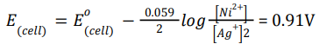 | 2
10 | During recharging, electrical energy is supplied to the cell from an external source. The reactions are reverse of those that takes place during discharge.  At cathode: PbSO₄ (s) +2e– → Pb(s) + SO₄^{2–}(aq)  At anode: PbSO₄ (s) + 2H₂O → PbO₂ (s) + 4H⁺(aq) + SO₄^{2–}(aq) + 2e–  Overall reaction: PbSO₄ (s) + 2H₂ O(l) → Pb(s) + PbO₂ (s) + 2H₂ SO₄ (aq) | 2
11 | (i) Octahedral splitting will takes place.  (ii) As Δ₀ > P pairing will occur in the t_{2g} orbitals and e_{g} orbitals will remain vacant. t_{2g}⁴ eg⁰ | 1  1

12 | 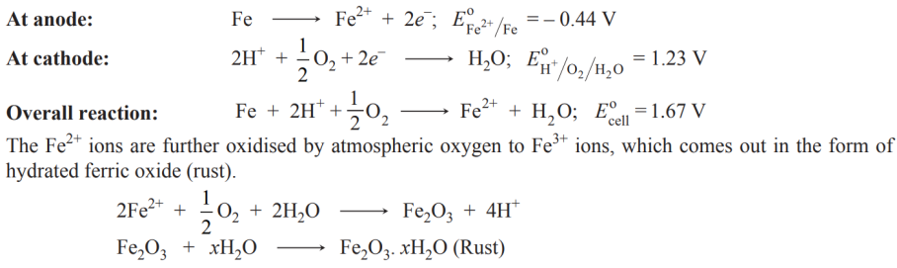 | 3
13 | Given:$Λ_{m}^{∘}\left({CH}_{3}COONa\right)=83 mho {cm}^{2}{mol}^{-1}$  $$Λ_{m}^{∘}\left(NaCl\right)=127 mho {cm}^{2}{mol}^{-1} \\ Λ_{m}^{∘}\left(HCl\right)=426 mho {cm}^{2}{mol}^{-1}$$$Λ_{m}^{∘}\left({CH}_{3}COOH\right)=$?  Using Kohlrausch law of independent migration of ions  $Λ_{m}^{∘}\left({CH}_{3}COOH\right)=Λ_{m}^{∘}\left({CH}_{3}COONa\right)+Λ_{m}^{∘}(HCl)-Λ_{m}^{∘}(NaCl)$ or  $$Λ_{m}^{∘}\left({CH}_{3}COOH\right)=83+426-127 \\ =382 mho {cm}^{2}{mol}^{-1}$$ | 3
14 | (i) A - [Co(NH₃)₅SO₄]Cl B - [Co(NH₃)₅Cl]SO₄  (ii) Ionisation isomerism  (iii) (A), Pentaamminesulphatocobalt (III) chloride  (B), Pentaamminechloridocobalt (III) sulphate. | 1  1  1

15 | (i)The amount of dissolved oxygen in water decreases with rise in the water's temperature. Cold water has more dissolved oxygen per unit area than warm water. This the reason why aquatic animals are more comfortable in cold water than warm water.  (ii) Solubility of gas in liquid decreases.  (iii)Any two applications  OR  (iii) According to Henry's law "the mass of a gas dissolved per unit volume of the solvent at constant temperature is directly proportional to the pressure of the gas in equilibrium with the solution".  P=K_{H}X | 1  1  2
16 | (a) This is because transition metals have strong metallic bonds as they have large number of unpaired electrons.  (b) This is because 5d and 4d-series elements have virtually the same atomic and ionic radii due to lanthanoid contraction.  (c) due to the fact that the 5f, 6d and 7s levels are of comparable energies.  (d)The high energy to transform Cu(s) to ${Cu}^{2+}$ (aq) is balanced by its hydration enthalpy.  (e) The stability of the half-filled d sub-shell in ${Mn}^{2+}$ and the completely filled $d^{10}$configuration in ${Zn}^{2+}$are related to their more negative E° V values.  (f) due to incomplete d orbitals and presence of unpaired electron.  (g)Because of fully filled d orbitals in zinc. | 1x5=5
17 | (a) t = 2.303/k log [A₀]/[A]  = 2.303/ 60 log 1/1/16 = 0.046 s  (b) log [k2/k1]= Ea / 2.303R[T2-T1/T1xT2]  Substituting the correct value and ans= 52.9kj/mol  OR  (a)(i) First order  (ii)Infinite, because no first order reaction is 100% completed.  (iii)k= Ae-Ea/RT, if Ea=0 then k =A, so the rate constant does not depend on temperature.  (b)Rate(R)=k[A][B]2  (i)Rate(R1) =k[A][B]2  (R1) =9R, so the rate increases 9 times.  (ii) R2= k[A][B]2  R2=8R,rate increases 8 times | 2  3  1x3  2x1

PRACTICE PAPER BOOK 1 SET- 02
SUBJECT: CHEMISTRY TIME: 1 ½ Hrs MM:37
CHEMISTRY PRACTICE PAPER BOOK 1 SET -01
Class: XII
S.No | Chapter | MCQ | A/R | VSA I | SA I | Case Based | LA | Total
S.No | Chapter | 1 Marks | 1  Marks | 2 Marks | 3 Marks | 4  Marks | 5  Marks
1 | Solutions | 2(2) |  |  |  |  | 5(1) | 7(3)
2 | Electrochemistry | 1(1) | 1(1) |  | 3(1) | 4(1) |  | 9(4)
3 | Chemical Kinetics | 1(1) |  | 2(1) |  | 4(1) |  | 7(3)
4 | d -and f -Block Elements | 2(2) |  | 2(1) | 3(1) |  |  | 7(4)
5 | Coordination Compounds |  |  | 2(1) |  |  | 5(1) | 7(2)
 | Total | 6(6) | 1(1) | 6(3) | 6(2) | 8(2) | 10(2) | 37(16)

Set 02
Practice Paper BOOK 1 (2023-24)
MM:37 CHEMISTRY THEORY (043) Time: 1 ½ hours
SECTION A
The following questions are multiple -choice questions with one correct answer. Each question carries 1 mark. There is no internal choice in this section.
1. Which of the following statements are true?
(i) Two different solutions of sucrose of the same molality prepared in different solvents will have the same depression in the freezing point.
(ii) The osmotic pressure of a solution is given by the equation Π = CRT
(iii) Decreasing order of osmotic pressure for 0.01 M aqueous solutions of barium chloride,
potassium chloride, acetic acid and sucrose is: BaCl₂ > KC l > CH₃COOH > sucrose.
(iv) According to Raoult’s law, the vapour pressure exerted by a volatile component of a solution is
directly proportional to its mole fraction in the solution.
(a) i, iii and iv (b) i, ii and iii (c) ii, iii and iv (d)i, ii and iv
2. 5L of 0.02 M aqueous solution of KCl was diluted by adding one litre of water. The molality of the
resultant solution is _____________.
(a) 0.0046 (b) 0.0086 (c) 0.0126 (d) 0.0166
3. Conductivity of an electrolytic solution depends on ____________.
(i) Nature of electrolyte. (ii) The concentration of electrolyte.
(iii) Power of AC source. (iv) Distance between the electrodes.
(a) (i) and (ii) (b) (i)and (iii) (c) (ii) and (iii) (d) (ii)and iv
- Which of the following statements is incorrect about the collision theory of chemical reaction? (a) It considers reacting molecules or atoms to be hard spheres and ignores their structural features.
(b) A number of effective collisions determine the rate of reaction.
(c) The collision of atoms or molecules possessing sufficient threshold energy results into the product formation.
(d) Molecules should collide with sufficient threshold energy and proper orientation for the
collision to be effective.
- Interstitial compounds are formed when small atoms are trapped inside the crystal lattice of metals. Which of the following is not the characteristic property of interstitial compounds?
(a) They have high melting points in comparison to pure metals.
(b) They are very hard.
(c) They retain metallic conductivity.
(d) They are chemically very reactive.

- Although Zirconium belongs to the 4d transition series and Hafnium to 5d transition series even
then they show similar physical and chemical properties because___________.
(a) both belong to d-block. (b) both have the same number of electrons.
(c) both have almost similar atomic radii. (d) both belong to the same group of the periodic table.
Given below (Q No 13 to 16)are two statements labelled as Assertion (A) and Reason (R)
Select the most appropriate answer from the options given below:
(a) Both A and R are true and R is the correct explanation of A
(b) Both A and R are true but R is not the correct explanation of A.
(c) A is true but R is false.
(d) A is false but R is true.
- Assertion: Current stops flowing when E_{cell} = 0.
Reason: Equilibrium of the cell reaction is attained.

.
SECTION B
This section contains 5 questions with internal choice in one question. The following questions are very short answer type and carry 2 marks each.
- What do you understand by the ‘order of a reaction’? Identify the reaction order from each of the
following units of reaction rate constant: (i) L⁻¹ mol s⁻¹ (ii) L mol⁻¹ s⁻¹
- Assign reasons for the following:
(i) Copper (I) ion is not known in aqueous solution.
(ii) Actinoids exhibit greater range of oxidation states than lanthanoids.
- Write the IUPAC names of the following coordination compounds:
(i) [CoCl₂(en)₂]⁺ (ii) [Cr(NH₃ )₃ (H₂O)₃ ]Cl₃
OR
Write the formulas for the following coordination compounds:
(i) potassium trioxalatoaluminate(III) (ii)diamminechloridonitrito-N-platinum(II)

SECTION C
This section contains 7 questions with internal choice in one question. The following questions are short answer type and carry 3 marks each.
- The following curve is obtained when molar conductivity, Δm is plotted against the square root of concentration, C^{1/2} along y and x-axis respectively for the two electrolytes X and Y.
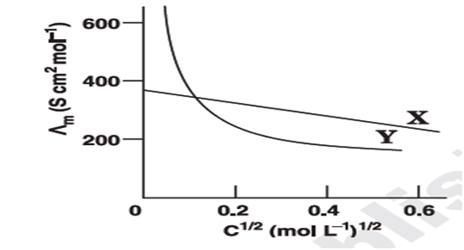
(i) What can you say about the nature of these two electrolytes?
(ii) How do you account for the increase in $Λ_{m}^{0}$ for the electrolytes X and Y with dilution?
(iii) How can you determine $Λ_{m}^{0}$ for these electrolytes?
- Compare the chemistry of actinoids with that of the lanthanoids with special reference to:
(i) Electronic configuration (ii) atomic and ionic sizes (iii) oxidation state

OR
Assign reason for the following
(i) Sc+³ is colourless while Ti⁺³is coloured.
(ii) Mn²⁺exhibit maximum paramagnetism.
(iii)${ E}^{0}$value for the ${Mn}^{+3}/{Mn}^{+2}$couple much more positive than that for ${Cr}^{+3}/{Cr}^{+2}$ .

SECTION D
The following questions are case -based questions. Each question has an internal choice and carries 4 (1+1+2) marks each. Read the passage carefully and answer the questions that follow.
- Read the following passage and answer questions given below:
A secondary cell after use can be recharged by passing current through it in the opposite direction so that it can be used again. A good secondary cell can undergo a large number of discharging and charging cycles. The most important secondary cell is the lead storage battery commonly used in automobiles and inverters. It consists of a lead anode and a grid of lead packed with lead dioxide (PbO₂ ) as cathode. A 38 % solution of sulphuric acid is used as electrolyte (density=1.294 g mL^{–1}). The battery holds 3.5 L of the acid. During the discharge of the battery, the density of H₂SO₄ falls to 1.139 g mL^{–1} (20% H₂SO₄ by mass).
a. Write the reaction taking place at the cathode when the battery is in use.
b. How much electricity (in Coulombs) is required to carry out the reduction of one mole of PbO₂?
c. The anodic half cell of Lead-Acid Battery is recharged using electricity of 0.05 Faraday. What amount in gram of PbSO₄ is electrolyzed during the process? The molar mass of PbSO₄= 303 g mol⁻¹
OR
Write reactions at cathode and anode during recharging of lead storage cell.
- Read the passage given below and answer the following questions:
The rate of a reaction, which may also be called its velocity or speed, can be defined with relation to the concentration of any of the reacting substances, or to that of any product of the reaction. If the species chosen is a reactant which has a concentration c at time t the rate is - dc/dt, while the rate with reference to a product having a concentration x at time t is dx/dt. Any concentration units may be used for expressing the rate; thus, if moles per litre are employed for concentration and seconds for the time, the units for the rate are moles liter-1 sec-1. For gas reactions pressure units are sometimes used in place of concentrations, so that legitimate units for the rate would be (mm. Hg) sec⁻¹ and atm. sec⁻¹. The order of a reaction concerns the dependence of the rate upon the concentrations of reacting substances; thus, if the rate is found experimentally to be proportional to the α th power of the concentration of one of the reactants A, to the β th power of the concentration of a second reactant B, and so forth, via.,
Rate = k C_{A} ^{α} C_{B} ^{β} ---------(1)
The over-all order of the reaction is simply
x = α + β + ----- ------- (2)
Such a reaction is said to be of the αth order with respect to the substance A, the β th order with respect to B and so on...
(Laidler, K. J., & Glasstone, S. (1948). Rate, order and molecularity in chemical kinetics. Journal of Chemical Education, 25(7), 383.)
a. For a reaction: P +2Q$⟶$Products , Rate = k [P]^{1/2}[Q]¹ . What is the overall order of reaction?
b. Write the rate equation for the reaction 2A + B → C if the order of the reaction is zero.
c. A reaction: Reactant $⟶$ Product is represented by the graph:

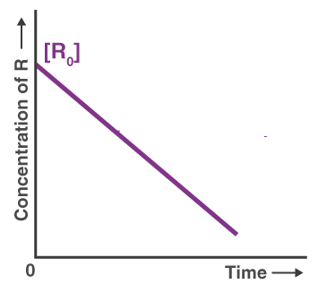

(i) Predict the order of the reaction.
(ii) What does the slope of the graph represent?
OR
Time required to decompose SO₂Cl₂ to half of its initial amount is 60 minutes.
If the decomposition is a first order reaction, calculate the rate constant of the reaction.
SECTION E
The following questions are long answer-type and carry 5 marks each. All questions have an internal choice.
- Answer any five questions from the following-
  - [Ni(CO)₄] is diamagnetic while [NiCl₄]²⁻ is paramagnetic although both have sp³ hybridization.Why?
  - Draw one of the geometrical isomer of [Co(en)₂Cl₂]⁺ which is optically active.
  - What type of isomerism is shown by the following complex compounds-? (i)[Co(NH₃)₆][Cr(CN)₆] (ii)[Cr(NH₃)₄ Cl(NO₂)]
  - Find the spin only magnetic moment of the complex K₄[Fe(CN)₆].
  - Write the electronic configuration of d⁴ on the basis of CFT when ∆_{o}>P.
  - Define Chelate complex.
  - Out of [CoF₆]³⁻ and [Co(en)₃]³⁺ which is paramagnetic?
- a) Explain the fact that Raoult’s Law is a special case of Henry’s Law.
b) H₂S, a toxic gas with a rotten egg like smell, is used for qualitative analysis. If the solubility of H₂S
in water at STP is 0.195 m, calculate Henry’s law constant.
c)A person cannot think properly at higher altitudes. Why? OR
a) Why is it not possible to obtain pure ethanol by fractional distillation?
b) Calculate the mass of ascorbic acid (C₆H₈O₆) to be dissolved in 75g of acetic acid to lower its melting point by 1.5^{о}C. (K_{f} =3.9K kgmol⁻¹).
c) Write two characteristics of the solution which obey Raoult’s law at all concentrations.

MARKING SCHEME PRACTICE PAPER SET -2
CLASS XII CHEMISTRY BOOK 1
1 | 2 | 3 | 4 | 5 | 6 | 7
C | D | A | B | C | D | A

Q.NO | ANSWERS/ HINTS | MARKS
8 | The sum of powers of the concentration of the reactants in the rate law expression is called the order of that chemical reaction.  r = K[A]^{x}[B]^{y} Order = x + y  (i) Zero order  (ii) Second order | 1  ½  ½
9 | (i) Cu²⁺(aq) is much more stable than Cu⁺(aq). This is because although second ionization enthalpy of copper is large but Δ_{hyd} (hydration enthalpy) for Cu²⁺(aq) is much more negative than that for Cu⁺(aq) and hence it more than compensates for the second ionization enthalpy of copper. Therefore, many copper (I) compounds are unstable in aqueous solution and undergo disproportionation as follows : 2Cu⁺ → Cu²⁺ + Cu  (ii) Because of very small energy gap between 5f, 6d and 7s subshells all their electrons can take part in bonding and shows variable oxidation states. | 1  1
10 | (i) Dichloridobis(ethane-1,2-diamine)cobalt(III)ion.  (ii) Triamminetriaquachromium(III) chloride | 1  1
OR | (i) K₃ [Al(C₂O₄ )₃ ] (ii) [Pt(NH₃ )₂Cl(NO₂ )] | 1+1
11 | (i) Electrolyte X is a strong electrolyte and Y is a weak electrolyte.  (ii) Molar conductivity, $Λ_{m}$ of X (strong electrolyte) increases slowly with dilution. This is because interionic forces of attraction decrease on dilution, although the number of ions remains the same. As a result ions move more freely and hence Lm increases with dilution.  On the other hand, for Y (weak electrolyte) $Λ_{m}$Lm increases sharply with dilution. This is because, degree of dissociation increases on dilution resulting in greater number of ions on dilution. Hence $Λ_{m}$ increases.  (iii) For X, $Λ_{m}^{0}$ can be obtained by extrapolation to zero concentration.For Y, $Λ_{m}^{0}$ can be calculated by using Kohlrausch law. | 1  1  1
12 | (i) Electronic configuration  The general electronic configuration for lanthanoids is [Xe]${4f}^{1-14}{5d}^{0-1}{6s}^{2}$ and that for actinoids is [Rn]${5f}^{1-14}{6d}^{0-1}7s^{2}$  (ii) Oxidation states  The principal oxidation state of lanthanoids is (+3). However, sometimes we also encounter oxidation states of + 2 and + 4. This is because of extra stability of fully-filled and half-filled orbitals. Actinoids exhibit a greater range of oxidation states. This is because the 5f, 6d, and 7s levels are of comparable energies. Again, (+3) is the principal oxidation state for actinoids. Actinoids such as lanthanoids have more compounds in +3 state than in +4 state.  (iii) Atomic and lonic sizes  Similar to lanthanoids, actinoids also exhibit actinoid contraction (overall decrease in atomic and ionic radii). The contraction is greater due to the poor shielding effect of 5orbitals. | 1x3
OR | i) Sc³⁺ have vacant d -subshell while Ti³⁺ have 1 electron in d subshell  ii) Mn²⁺ have 5 unpaired electron which are maximum in d- sub shell  iii) Much larger third ionisation energy of Mn (where the required change is d⁵ to d⁴) is mainly responsible for this. | 1+1+1
13 | a. PbO₂ (s) + SO₄^{2–} (aq) + 4H⁺ (aq) + 2e– → PbSO₄ (s) + 2H₂O (l)  b. 2 F = 2 × 96500 = 193000 C  c. 2 Faraday of electricity = 303 gm PbSO₄  0.05F= 0.05/2*303=7.6 gm  OR  Recharge reaction of cell: It changes the direction of electrode reaction. PbSO₄ accumulated at cathode gets reduced to Pb.  At cathode: PbSO₄ (s) +2e– → Pb(s) + SO₄^{2–}(aq)  At anode: PbSO₄ gets oxidised to PbO₂  PbSO₄ (s) + 2H₂O → PbO₂ (s) + 4H⁺(aq) + SO₄^{2–}(aq) + 2e–  Overall Reaction: PbSO₄ (s) + 2H₂O(l) → Pb(s) + PbO₂ (s) + 2H₂SO₄ (aq) | 1x3
14 | (a) 1.5  (b) Rate = k [A]0[B]0 or Rate = - k  (c) (i) Zero order (ii) Slope = – k  OR  t _{½}= .693/λ = .693/60= .01155 min , =1.925 x 10⁻⁴s⁻¹
15 | a) In Ni(CO)₄​, the oxidation state of Ni is zero whereas in [NiCl_{4​]}²⁻, the oxidation state of Ni is +2.The presence of CO ligand, which is a strong ligand, can pair all electrons in Ni(CO)₄​ and thus it is diamagnetic in nature but Cl− is a weak ligand and is unable to pair up the unpaired electrons and thus [NiCl₄​]²⁻ is paramagnetic in nature.  b)  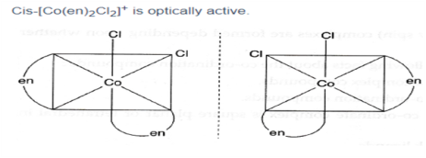  c) i)Coordination isomerism ii) Linkage isomerism  d)  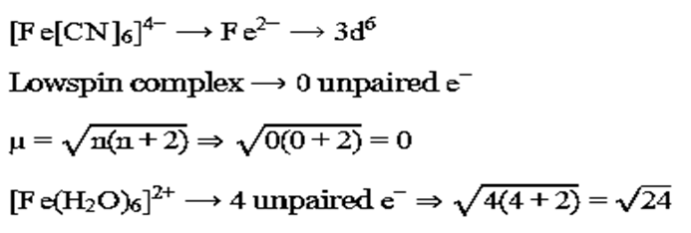  e) t_{2g}⁴  f)bidentate or polydentate ligands form ring like structures with metal atom or ion is called chelate complex.  g)[CoF₆]³⁻ | 1  1  1  1  1  1
16 | a)According to Henry’s law:p=K_{H}x  According to Raoult’s law:p=p⁰x  Where p is the partial pressure, x is the mole fraction and K_{H} is the proportionality constant (Henry’s constant)  We can see that the partial pressure of the volatile component or gas is directly proportional to its mole fraction in solution by comparing the above equations. As a result, where K_{H}=p⁰, Raoult's law is a particular instance of Henry's law  b)According to Henry's Law,P=K_{H}×χ  K_{H}=Henry's constant, χ=mol fraction  At STP, P = 1 atm  0.195 m means 0.195 mol of gas is dissolved in 1 kg of solvent (water)  nH₂O=1000 g/18 g mol⁻¹  Mol fraction of H₂S = nH₂S/nH₂S+nH₂O χH₂S=0.195/0.195+1000/18=0.0035⇒P=K_{H}×χ⇒K_{H}=1.000.0035≈285.7 atm  c) At higher altitudes, the oxygen concentration remains the same, but air pressure is much lower. (Anoxia) | 2  2  1
OR | a)It not possible to obtain pure ethanol by fractional distillation because it forms an azeotrope.  b)Mass of acetic acid, w₁= 75 g Molar mass of ascorbic acid (C_{6​}H₈​O₆​), M₂=6×12+8×1+6×16=176gmol−1  Lowering of melting point, ΔT_{f​} =1.5K We know that:  ΔT_{f}= ​K_{f}​×1000×w₂ / M₂​×w_{1​​} w₂​= ΔT_{f}​×M₂​×w₁ / K_{f}​×1000​​  w₂​=1.5×176×75 /3.9×1000​ w₂​=5.08g, Hence, 5.08 g of ascorbic acid is needed to be dissolved.  c)The characteristics are  It heat change of mixing should be zero  it's volume change in mixing should be zero  The solution which obeys this law is also known as Ideal solution. | 1  3  1

PRACTICE PAPER BOOK 1 SET -3
Class XII Chemistry
S.No. | Name of Chapter | MCQ | A/R | SA1 | SA2 | Case Base | LA | Total
S.No. | Name of Chapter | 1 mark | 1 Mark | 2 Mark | 3 mark | 4 Mark | 5 mark
1 | Solutions | 1(1) | 1(1) | 2(1) | 3(1) | - |  | 7(4)
2 | Electrochemistry | 1(1) | - |  | 3(1) | - | 5(1) | 9(3)
3 | Chemical Kinetics | 1(1) | - | 2(1) |  | 4(1) |  | 7(3)
4 | d and f Block Elements | - | - |  | 3(1) | 4(1) |  | 7(2)
5 | Coordination Compounds | 2(2) | - |  |  | - | 5(1) | 7(3)
 | Total | 5(5) | 1(1) | 4(2) | 9(3) | 8(2) | 10(2) | 37(15)

Set 03
Practice Paper BOOK 1 (2023-24)
MM:37 CHEMISTRY THEORY (043) Time: 1 ½ hours

 | SECTION-A
1 | Limiting molar conductivity of NH₄OH is equal to –  a)ΛºmNH₄Cl +ΛºmNaCl + ΛºmNaOH  b)ΛºmNaOH + ΛºmNaCl - ΛºmNH₄Cl  c)ΛºmNaOH -ΛºmNH₄Cl - ΛºmHCl  d)ΛºmNH₄Cl +ΛºmNaOH - ΛºmNaCl | 1
2 | A first order reaction has a rate constant1.15×10⁻³s-¹. How long time will 5g of this  reactant take to reduce to3g?  (a)444 s (b) 400 s (c) 528 s (d) 669 s | 1
3 | Which is most covalent Mn₂O₇ or MnO₂ or MnO?  a) Mn₂O₇ b) MnO c) MnO₂ d) Both MnO and MnO₂ | 1
4 | Of the following complex ions, which is diamagnetic in nature –  (a) [Ni(CO)₄] (b) [FeCl₆]²⁻ (c) [CoF₆]³⁻ (d) [NiCl₄]²⁻ | 1
5 | The hybridization involved in complex [Ni(CN)₄]²⁻(Atomic number of Ni = 28) is  (a) dsp² (b) sp³ (c)d²sp² (d) d²sp³ | 1
Assertion-and-Reason Type Questions:

Each question consists of two statements, namely, Assertion (A) and Reason (R). For selecting the correct answer, use the following code:

(a) Both Assertion (A) and Reason (R) are the true and Reason (R) is a correct explanation of Assertion (A).
(b) Both Assertion (A) and Reason (R) are the true but Reason (R) is not a correct explanation of Assertion (A).
(c) Assertion (A) is true and Reason (R) is false.
(d) Assertion (A) is false and Reason (R) is true.

6 | Assertion(A) :-Sprinkling of salt helps in clearing the snow-covered roads in hills.  Reason(R):-Salt decreases the freezing point of snow. | 1
 | SECTION-B
7 | The rate of a reaction quadruples when the temperature changes from 293K to 313K. Calculate the energy of activation of the reaction assuming that it does not changes with temperature.  (log 2 = 0.30, log 4 = 0.60) {R=8.314Jk⁻¹mol⁻¹} | 2
8 | For a 5% solution of urea (Molar mass=60g/mol), calculate the osmotic pressure at 300K. {R=0.0821KatmJ⁻¹mol⁻¹ | 2
 | SECTION-C
9 | When 1.5 g of a non-volatile solute was dissolved in 90 g of benzene, the boiling point of benzene raised from 353.23 K to 353.93 K. Calculate the molar mass of the solute.  (K_{b}for benzene = 2.52 K kg mol–1) | 3
10 | How much charge is required for the following reduction:  (i) 1 mol of Al³⁺ to Al? (ii) 1 mol of Cu²⁺ to Cu? (iii) 1 mol of MnO₄– to Mn²⁺? | 3
11 | write the ionic equations when potassium dichromate reac withthe following-  (i) iodide (ii) ironsulphate solution (iii) H₂S. | 3
 | SECTION-D
12 | Read the following paragraph and answer the given questions:  Zero order system provide an interesting opportunity for students to think about the underlying mechanism behind the physical phenomenon being modelled. The work reported here is part of a larger study that seeks to characterize how students integrate chemistry and mathematics in the context of chemical kinetics. Thirty-six general chemistry students, five physical students and three chemical engineering students were asked to think a loud as they responded to an interview prompt about the half-life of catalyst –driven zero-order reaction. Our findings revealed that students often described zero-order in mathematical terms (i.e. the zero- order rate law, integrated rate law and graphical representation), but lacked a clear understanding of the particulate nature of zero-order system.  - Write unit of rate constant for zero-order reaction.  - Give an example of zero-order reaction.  - Define half- life of a reaction. Give the expression to calculate half life period for zero order reaction  OR  (C )Time required to decompose SO₂Cl₂ to half of its initial amount is 60 minutes.  If the decomposition is a first order reaction, calculate the rate constant of the  reaction. | 1  1  2
13 | Read the following paragraph and answer the given questions:  The d-block metals are central within the periodic table and are at the core of numerous branches of inorganic chemistry, including material chemistry, applied biological and analytical sciences, and catalysis. The term transition metal is still much used but this strictly excludes the group 10 metals (Zn, Cd and Hg) since IUPAC defines a transition metal as an element whose atom has an incomplete d-subshell, or which can give rise to cation with an incomplete d sub-shell. The traditional picture of the d-block is often triads or three rows of metallic elements. The fourth row ( Ac, Rf-Cn) is often ignored by those us who teach inorganic chemistry courses, largely because of the elements from Rutherfordium( Rf, Z=104) onwards.  (a) What is the general electronic configuration of transition elements.  (b) Name a metal of 1st transition series exhibits +1 oxidation state.  (C) What is Lanthanoid contraction? Name the alloy formed by Lanthanoids?  OR  (C)Use Hund’s rule to derive the electronic configuration of Ce⁴⁺ ion and calculate its magnetic moment on the basis of spin only formula. | 1  1  2
 | SECTION-D
14 | Attempt any five of the following:  - Write IUPAC names of the coordination compound [Co (NH₃)₄Cl (NO₂)] Cl  - CuSO₄ .5H₂O is blue in colour while CuSO₄ is colourless. Why?  - Arrange following complex ions in increasing order of crystal field splitting energy (Δ₀)  - [Cr (Cl)₆]³⁻ , [Cr(CN₆) ]³⁻ , [Cr(NH₃)₆ ]⁺³  - Name the type of isomerism when ambidentate ligands are attached to central metal ion.  - Calculate magnetic moment of [Fe (H₂O)₆ ]⁺³  - Write one example of a complex which is homoleptic.  - What is the relationship between observed colour of the complex and the wavelength of light absorbed by the complex? | 1  1  1  1  1  1  1
15 | A strip of nickel metal is placed in a 1 molar solution of $Ni{\left({NO}_{3}\right)}_{2}$ and a strip of silver metal is placed in a 1 molar solution of ${AgNO}_{3}$. An electrochemical cell is created when the two solutions are connected by a salt bridge and the two strips are connected by wires to a voltmeter.  (i) Write the balanced equation for the overall reaction occurring in the cell and calculate the cell potential.  (ii) Calculate the cell potential, $E$, at ${25}^{∘}C$ for the cell if the initial concentration of $Ni{\left({NO}_{3}\right)}_{2}$ is $0.100$ molar and the initial concentration of ${AgNO}_{3}$ is $1.00$ molar.  $$\left[E_{{Ni}^{2+}/Ni}^{0}=-0.25V;E_{{Ag}^{+}/Ag}^{0}=0.80V,log⁡{10}^{-1}=-1\right]$$  OR  Answer the following questions based on electrochemical cells:  - What will be the sign of ΔG for an electrochemical cell and an electrolytic cell?  - Standard electrode potentials of three metals X, Y and Z are 0.52V, -2.87 V and  -0.44 V respectively. What will be the order of reducing power of these metals?  - Calculate emf of the following cell at 25°C:  Fe | Fe²⁺ (0.001 M) || H⁺ (0.01 M) | H₂(g) (1 bar) | Pt(s)  Eº(Fe²⁺ | Fe) = -0.44 V and Eº(H⁺ | H₂) = 0.00V | 5  1  1  3

PRACTICE PAPER BOOK 1 SET-3
Class XII Chemistry
Answer Key

Q.NO. | ANSWER | MARKING
1 | D
2 | A
3 | A
4 | A
5 | A
6 | A
7 | 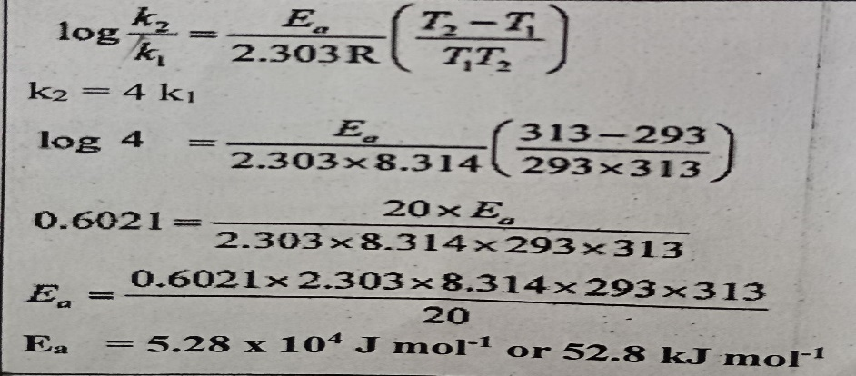 | ½  1  1/2
8 | Osmotic pressure=W x R x T/M x V  Calculation  Answer (20.525atm) | ½  1  1/2
9 |  | ½  1  ½
10 |  | 1  1  1
11 |  | 1  1  1
12 | - Mol L⁻¹ s⁻¹  - Decomposition of Ammonia on platinum wire or any other correct  (c) The time period in which concentration of reactants reduced to half of its initial concentration.  $t_{1/2}=\frac{{[R]}_{0}}{2K}$  OR  (c ) t _{½} = 0.693/k  = 0.639/60x60 ; k= 1.925x10⁻⁴ s⁻¹ | 1  1  1+1  ½+1+½
13 | - (n-1)d¹⁻¹⁰ ns ¹⁻²  - Copper  (c )The regular decrease in size of lanthanides due to poor shielding effect , is called lanthanide contraction.  Alloy- misch metal  OR  Ce³⁺ = [Xe]4f¹  Magnetic moment = $μ$= $\sqrt{n(n+2)}$  Here n=1, hence , µ = $\sqrt{1(1+2)}$  =1.3 BM | 1  1  1+1  ½+1+½
14 | a)Tetraamminechloridonitro-N-cobalt (III) chloride  b)In CuSO₄.5H₂O water acts as ligand and causes crystal field splitting. Hence, d-d transition is possible  thus CuSO₄.5H₂O is coloured. In the anhydrous CuSO4 due to the absence of water (ligand), crystal field  splitting is not possible and hence, it is colourless.  c) [Cr (Cl)₆] ³⁻< [Cr(NH₃)₆ ] ⁺³<[Cr(CN₆) ]³  d) Linkage Isomerism  e)5.92 BM as 5 unpaired electrons are present.  f) [Cr(NH₃)₆ ]⁺³  g)When white light falls on the complex, some part of it is absorbed. Higher the crystal field splitting energy, lower will be the wavelength absorbed by the complex. The observed colour of complex is the colour generated from the wavelength left over. e g. ., if green light is absorbed, the complex appears red. | 1  1  1  1  1  1  1
15 | (i)Cell reaction: Ni + 2Ag⁺ → Ni²⁺ + 2Ag, E°_{Cell} = E°_{cathode}- E°_{anode,} E°_{Cell =} 1.05V  (ii)$E_{\text{cell }}=E_{\text{cell }}^{o}-\frac{0.059}{n}\log{\frac{\left[{Ni}^{2+}\right]}{{\left[{Ag}^{+}\right]}^{2}}}$ = 1.0795V  OR  a) ΔG for an electrochemical cell is -ve and ΔG for an electrolytic cell is +ve.  b)Y > Z > X  c)For the given cell representation,the cell reaction will be  Fe_{(S)} + 2H⁺(aq)→Fe²⁺(aq)+H₂(g)  The standard emf of the cell will be  $$E_{cell}^{0}=E_{H+/H2}^{0}-E_{Fe2+/Fe}^{0}$$  $$E_{cell}^{0}=0-\left(0.44\right)=+0.44 V$$  The nernst equation for the cell reaction at 25⁰ C will be  $${ E}_{cell}=E_{cell}^{0}-\frac{0.0591}{n}log\frac{[{Fe}^{2+}]}{[H^{+}]^{2}}$$  $${ E}_{cell}=0.44-\frac{0.0591}{n}log\frac{[0.001]}{[0.01]^{2}}$$  $${ E}_{cell}=0.41 V$$ | 2  3  1  1  3

PRACTICE PAPER BOOK 1 SET-04
CLASS XII CHEMISTRY BLUE PRINT

S.No. | Name of Chapter | MCQ | A/R | SA1 | SA2 | Case Base | LA | Total
S.No. | Name of Chapter | 1 mark | 1 Mark | 2 Mark | 3 mark | 4 Mark | 5 mark
1 | Solutions | 1(1) |  | 2(1) | - | 4(1) |  | 7(3)
2 | Electrochemistry |  | 1(1) | 2(1) | 6(2) |  |  | 9(4)
3 | Chemical Kinetics | 2(2) |  |  | - |  | 5(1) | 7(3)
4 | d and f Block Elements | - |  |  | 3(1) | 4(1) |  | 7(2)
5 | Coordination Compounds | 2(2) |  |  | - |  | 5(1) | 7(3)
 | Total | 5(5) | 1(1) | 4(2) | 9(3) | 8(2) | 10(2) | 37(15)

Set 04
Practice Paper BOOK 1 (2023-24)
MM:37 CHEMISTRY THEORY (043) Time: 1 ½ hours

1 | The experimental molar mass of an electrolyte will be less than its calculated value because of the value of van't Hoff factor is  - less than 1 b. greater than 1  c. one d. zero
2 | A plot is shown below between concentration and time t. Which of the given order is indicated by the graph  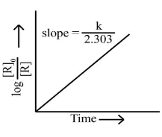  (a) Zero Order (b) Second Order (c) First Order (d) Fractional Order
3 | The reaction NO₂ + CO → NO + CO₂ takes place in two steps. Find the rate law.  2NO₂ → NO + NO₃ – slow  NO₃ + CO → CO₂ + NO₂ – fast  - R = k [NO₂ ]³  - R = k [NO₃] [CO]  - R = k [NO₂ ]  - R = k [NO₂ ]²
4 | Out of the following coordination entities, which is chiral (Optically active)  (a) Cis-[CrCl₂(Ox)₂]³⁻  (b) trans- [CoCl₂(en)₂]⁺  (c) [Fe(CN)₆]³⁻  (d) [co(NH₃)₅(NO₂)]⁺²
5 | Co-ordination ions [Ni(CN)₄]²⁻ and [NiCl₄]²⁻ have  (a) Tetrahedral, Paramagnetic and Square planar, diamagnetic  (b) Square Planar, diamagnetic and Tetrahedral, Paramagnetic  (c) Tetrahedral, diamagnetic and square Planar, diamagnetic  (d) Square Planar, Paramagnetic and tetrahedral, Paramagnetic
6 | Instructions for question number 6.  (a)Assertion and reason both are correct and reason is correct explanation of assertion.  (b) Assertion and reason both are correct statements but reason is not correct explanation of assertion  (c) Assertion is correct but reason is wrong statement.  (d) Assertion is wrong but reason is correct statement.  Assertion: SHE (Standard hydrogen electrode) consists of a platinum electrode coated with platinum black.  Reason: it’s standard electrode potential is taken as 1.00 volt
 | SECTION -B
7 | An aqueous solution of sodium chloride freezes below 273 K. Explain the lowering in freezing points of water with the help of a suitable diagram
8 | The molar conductivity of a 1.5 M solution of an electrolyte is found to be 138.9 Scm²mol¹⁻. Calculate the conductivity of this solution.  OR  Calculate the time to deposit 1.27 g of copper at cathode when a current of 2A was passed through the solution of CuSO₄.  (Molar mass of Cu = 63.5 g mol⁻¹,1 F = 96500 C mol⁻¹)
 | SECTION -C
9 | Account for the following  - Cu⁺ ion is not stable in aqueous solutions  - d¹ configuration is very unstable in ions.  - E⁰ value for the Mn²⁺/ Mn much more than expected.
10 | Calculate emf of the following cell at 25 °C:  Fe|Fe²⁺(0.001 M) || H⁺(0.01 M) | H₂(g) (1 bar) | Pt(s)  E°(Fe²⁺|Fe) = -0.44V, E°(H⁺|H₂) = 0.00 V
11 | Account for the following  (i) Rusting of iron is quicker in saline water than in ordinary water.  (ii) Blocks of magnesium are strapped to the steel hubs of ocean-going ships.  (iii) State the low of Kohlrausch.
 | SECTION -D
12 | Read the passage given below and answer the following case-based questions:  Boiling point or freezing point of liquid solution would be affected by the dissolved solids in the liquid phase. A soluble solid in solution has the effect of raising its boiling point and depressing its freezing point. The addition of non-volatile substances to a solvent decreases  the vapour pressure and the added solute particles affect the formation of pure solvent crystals. According to many researches the decrease in freezing point directly correlated to the concentration of solutes dissolved in the solvent. This phenomenon is expressed as freezing point depression and it is useful for several applications such as freeze concentration of liquid food and to find the mass of an unknown solute in the solution. Freeze concentration is a high-quality liquid food concentration method where is removed by forming ice crystals. This is done by cooling the liquid food below the freezing point of the solution. The freezing point depression is referred as a colligative property and it is proportional to the concentration of the solution (m), along with vapour pressure relative lowering, boiling point elevation, and osmotic pressure. These are physical characteristics of solutions that depend only on the identity of the solvent and the concentration of the solute. The characters are not depending on the solute’s identity.  (a) What is the relation between vapour pressure of solid and liquid states of particular  substance at freezing point?  (b)Why freezing point of 0.1m solution of acetic acid in benzene is less than freezing point of 0.01m solution?  (c) Out of the following 0.10 m aqueous solutions, which one will exhibit the largest freezing point depression KCl, C₆H₁₂O_{6,} Al₂(SO₄)_{3 ,} K₂SO₄  OR  (c) If K_{f} for water is 1.86 º C/m, explain why 1m NaCl in water does not have a freezing point equal to- (a) -1.86 ºC ( b) -3.72ºC
13 | Read the passage given below and answer the following questions:  The transition elements have incompletely filled d-subshells in their ground state or in any of their oxidation states. The transition elements occupy position in between s- and p-blocks in groups 3-12 of the Periodic table. Starting from fourth period, transition elements consists of four complete series: Sc to Zn, Y to Cd and La, Hf to Hg and Ac, Rf to Cn. In general, the electronic configuration of outer orbitals of these elements is (n - 1) d¹⁻¹⁰ ns¹⁻². The electronic configurations of outer orbitals of Zn, Cd, Hg and Cn are represented by the general formula (n - 1)d¹⁰ n². All the transition elements have typical metallic properties such as high tensile strength, ductility, malleability. Except mercury, which is liquid at room temperature, other transition elements have typical metallic structures. Transition metal also forms alloys. An alloy is a blend of metals prepared by mixing the components. Alloys may be homogeneous solid solutions in which the atoms of one metal are distributed randomly among the atoms of the other.  (a). Why transition metals are associated with higher catalytic activity?  (b). why, Zn, Cd & Hg are not considered as a transition metals.  OR  (b). What are the constituents of Mischmetal.  (c). Arrange the following metal complex in increasing order of their magnetic moments.  (i)[Fe(CN)₆]⁴⁻ (ii) [Fe(CN)₆]³⁻ (iii)[Cr(NH₃)₆]³⁺ (iv)[Ni(H₂O)₄]²⁺
 | SECTION -E
14 | Attempt any 5 questions  (a). For a reaction R → P, half-life (t_{1/2}) is observed to be independent of the initial  concentration of reactants. What is the order of reaction?  (b). Express the rate of the following reaction in terms of the formation of ammonia:  N₂(g) + 3H₂(g) → 2NH₃(g)  (c). Rate constant k for a first order reaction has been found to be 2.54 × 10⁻³ s⁻¹. Calculate its  (3/4) ^{th} life, (log 4 = 0.6020)  (d). Write two differences between ‘order of reaction’ and ‘molecularity of reaction’.  (e). For a chemical reaction R → P, variation in ln[R] vs time (f) plot is given below:  For this reaction  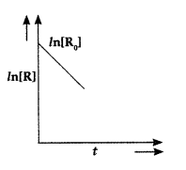  (i)Predict the order of reaction  (ii) What is the unit of rate constant (k)?  (f). Rate constant ‘k’ of a reaction varies with temperature ‘T’ according to the equation:  log k = log A – Ea / 2.303R(1/ T)  Where E_{a} is the activation energy. When a graph is plotted for log k vs. 1/T, a straight line with a slope of – 4250 K is obtained. Calculate ‘E_{a}‘ for the reaction. (R = 8.314 JK¹ mol⁻¹)  (g) With the help of diagram explain the role of activated complex in a reaction
15 | (i) What type of isomerism is shown by the complex [Co(NH₃)₅ SCN]²⁺?  (ii) Why is [NiCl₄]²⁻ paramagnetic while [Ni(CN)₄]²⁻ is diamagnetic? (Atomic number of Ni = 28)  (iii) Why are low spin tetrahedral complexes rarely observed?  (iv)For the complex ion [Fe(en)₂Cl₂]⁺ write the hybridization type and magnetic behaviour.  Draw one of the geometrical isomers of the complex ion which is optically active.  [Atomic No.: Fe = 26]  Or  (i) Draw the geometrical isomers of complex [Pt(NH₃)₂Cl₂].  (ii) On the basis of crystal field theory, write the electronic configuration for d⁴ ion if Δ₀ < P.  (iii) How is a double salt different from a complex?  (iv) Write the hybridization and magnetic behaviour of the complex [Ni(CO)₄].  (At. no. of Ni = 28)
PRACTICE PAPER BOOK 1 SET 4
CLASS XII CHEMISTRY
Marking Scheme
1 | 2 | 3 | 4 | 5 | 6
b | c | d | a | b | c
7 | An aqueous solution of sodium chloride freezes below 273 K because vapour pressure of the solution is less than that of the pure solvent  .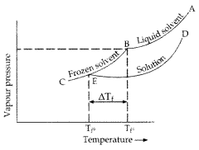 | 1+1
8 | 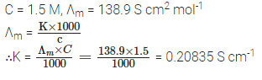  OR  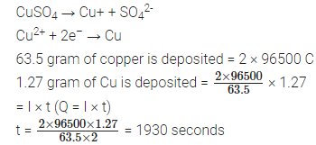 | ½+1+1/2
9 | Ans: (a) Hydration enthalpy of Cu²⁺ ion is more that compensate the second ionization enthalpy.  (b) The ions in d¹ configuration tend to lose one more electron to get into stable d⁰ configuration  (c) due to greater stability of half-filled d-subshell (d⁵) in Mn²⁺ | 1+1+1
10 | E_{cell} = E⁰_{cell}– (.0592/n) log [Fe⁺²]/[H₂]²  n = 2  E⁰_{cell} = E⁰_{H+/H2} - E⁰_{Fe+2/Fe} = 0 –( -0.44) = 0.44 V  [Fe⁺²] =[10⁻³] [H₂]² = [10⁻²]²  Ans- E_{cell} = 0.4105 V | ½+1+1+ ½+
11 | (i)Strong electrolytes such as sodium chloride are present in saline water. The ions produced from NaCl help in the reduction of oxygen to form water. Hence, the rusting of iron is faster in saline water than in pure water.  (ii) Blocks of magnesium are often stepped to steel hulls of ocean-going ships as magnesium causes cathodic protection of iron. Magnesium is more reactive than iron.  (iii) Kohlrausch's law states that the equivalent conductivity of an electrolyte at infinite dilution is equal to the sum of the conductance’s of the anions and cations. | 1+1+1
12 | (a)Equal  (b)Depression in FP in 0.1m solution is more than 0.01 solution so FP of first is less.(change in freezing point is directly proportional to molality)  (c)Al₂(SO₄)₃  OR  a) as there are 2 moles of ions per mol of NaCl  b) degree of ionisation is not 100% at freezing point due to stronger interactions for 1m solution | 1+1+2
13 | (a)Variable oxidation state and provide large surface area  (b) fully filled d¹⁰ electronic configuration  or  (b)95% lanthanides and 5% iron  (c)iv < iii < i < ii | 1+1+2
14 | (a) first order  (b) Rate = -d[N₂]/dt =-d1[H₂]/3dt =+ d[NH₃]/2dt  (c) T_{3/4} = (2.303/K) log R₀/R_{t} = 2.303/2.54x10-3 log (100/25) = 9.09 min  (d)Molecularity is defined as the number of reacting molecules taking part in the rate-determining step  Molecularity of reaction is always in a whole number or integer; it can never be fraction or zero  Order is defined as the sum of the powers of the concentration of reactants taking part in a rate low  Order of reaction can be a whole number, zero, integer, or fraction (any other 2)  (e)(i) First order  (ii) S⁻¹  (f) Slope - Ea/2.303 R = - 4250 K  E_{a} = 2.303 × 8.314 (JK⁻¹ mol⁻¹) × 4250 K  = 81.375 J mol⁻¹ or 81.375 kJ mol⁻¹  (g)  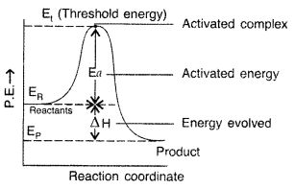 | 1x5
15 | (a) [Co(NH₃)₅ (SCN)]²⁺ shows linkage isomerism.  (b) Since in [NiCl₄]²⁻ Cl– is a weak field ligand, it forms outer orbital complex and has unpaired electrons which imparts paramagnetic character to complex while in [Ni(CN)₄]²⁻, CN– is a strong field ligand, forms inner orbital complex and has paired electrons which imparts diamagnetic character to it.  (c) Low spin tetrahedral complexes are rarely observed because orbital splitting energies for tetrahedral complexes are not sufficiently large for forcing pairing.  (d) hybridisation d₂sp3 and paramagnetic only cis isomer show optical isomerism.  Or  (i)  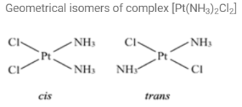  (ii)Electronic configuration for d⁴ ion if Δ₀ < P is t_{2g}³e_{g}¹ (high spin complex is formed)  (iii)  (iv) Ni(CO)₄ has sp³ hydbridization. It is diamagnetic in nature. | 1+1+1+2  1+1+1+2
  Double salt | Complex salt
  A double salt is a combination of two salt compounds. | A complex salt is a molecular structure that is composed of one or more complex ions.
  Double salts can give simple ions when added to water. | Complex salts do not give simple ions when added to water

PRACTICE PAPER SET-05
CLASS:XII CHEMISTRY THEORY (043) BOOK 01

Sr. No. | CHAPTER NAME | MCQ  (1 MARKS ) | MCQ ASSERTION REASON (1 MARKS) | VSA  (2 MARKS) | SA  (3 MARKS) | Case study (4 MARKS) | LONG ANSWER  (5 MARKS ) | TOTAL  MARKS
1 | SOLUTION | -- | 2(2) | -- | -- | -- | 5(1) | 7(3)
2 | ELECTROCHEMISTRY | 2(2) | -- | 4(2) | 3(1) | -- | -- | 9(5)
3 | CHEMICAL KINETICS | 2(2) | -- | 2(1) | 3(1) | -- | -- | 7(4)
4 | d and f BLOCK ELEMENTS | 2(2) | -- | -- | -- | -- | 5(1) | 7(3)
5 | COORDINATION COMPOUNDS | 1(1) | -- | 2(1) | -- | 4(1) | -- | 7(3)
 |  | 7(7) | 2(2) | 8(4) | 6(2) | 4(1) | 10(2) | 37(18)
  TOTAL (MARKS)

S.N. | Set 05  Practice Paper BOOK 1 (2023-24)  MM:37 CHEMISTRY THEORY (043) Time: 1 ½ hours | MARKS
 | SECTION-A
1 | The number of electrons delivered at the cathode during electrolysis by a current of 1 ampere in 60 seconds is (charge on electron = 1.60 x 10⁻¹⁹ C)  (a) 6 x 10²³ (b) 6 x 10²⁰  (c) 3.75 x 10²⁰ (d) 7.48 x 10²³ | 1
2 | For a general chemical change 2A+3B- Product. The rate of disappearance of A is r₁ and of B is r₂ .The rates of r₁ and r₂ are related as  (a) 3r₁ =2r₂ (b) r₁=r₂  (c) 2r₁=3r₂ (d) r₁² =2r₂² | 1
3 | According to collision theory of reaction rates-  (a)Every collision between reactant leads to chemical reaction  (b)Rate of reaction is proportional to velocity of molecule  (c)All reaction which occurs in gaseous phase are zero order reaction  (d)rate of reaction is directly proportional to collision frequency
4 | Zinc is used to protect iron from corrosion because  (a) E_{oxi} of zinc is less than E_{oxi} of iron (b) E_{red} of zinc is less than E_{red} of iron  (c) Zinc is cheaper than iron (d) Zinc is abundantly available | 1
5 | Cerium (Z = 58) is an important member of the lanthanoids. Which of the following statement about Cerium is incorrect?  (a) The common oxidation states Cerium are + 3 and + 4.  (b) The + 3 oxidation state of Cerium is more stable than + 4 oxidation state.  (c) The + 4 oxidation state of Cerium is not known in solutions.  (d) Cerium (IV) acts as an oxidizing agent. | 1
6 | Amongst [Ni (CO)₄], [Ni(CN)₄]²⁻ and [NiCl₄]²⁻  (a) [Ni (CO)₄]and [NiCl₄]²⁻ are diamagnetic and [Ni(CN)₄]²⁻ is paramagnetic  (b) [NiCl₄]²⁻ and [Ni(CN)₄]²⁻ are diamagnetic and [Ni (CO)₄] is paramagnetic.  (c) [Ni (CO)₄]and [Ni(CN)₄]²⁻ are diamagnetic and [NiCl₄]²⁻ is paramagnetic.  (d) [Ni (CO)₄]is diamagnetic and [NiCl₄]²⁻ and [Ni(CN)₄]²⁻ are paramagnetic. | 1
7 | Colour of transition metal ions are due to absorption of some wavelength. This results in  (a) p-p transition (b) f-f transition  (c) s-p transition (d) d-d transition | 1
Question number 13 to 16 are assertion and reasoning-based questions.
Select the most appropriate answer from the options given below.
(a) Both A and R are true and R is the correct explanation of A.
(b) Both A and R are true but R is not the correct explanation of A.
(c) A is true but R is false.
(d) A is false but R is true.
8 | Assertion (A): When NaCl is added to water a depression in freezing point is observed.  Reason (R): The lowering of vapour pressure of a solution causes depression in the freezing point. | 1
9 | Assertion (A): Azeotropic mixtures are formed only by non-ideal solutions and they may have boiling points either greater than both the components or less than both the components.  Reason (R): The composition of the vapour phase is same as that of the liquid phase of an azeotropic mixture. | 1
 | SECTION-B
10 | Write the chemical equation involved during discharging of Lead Storage cell.  OR  Write the anodic and cathodic cell reactions of hydrogen- oxygen Fuel Cell. | 2
11 | A First order reaction takes 30 minutes for 50% completion. Calculate the time required for 90% completion of this reaction. (log 2 = 0.3010) | 2
12 | The conductivity of 0.20 M solution of KCl at 298 K is 0.0248 S cm⁻¹. Calculate its molar conductivity. | 2
13 | i) Define crystal field splitting energy.  ii) On the basis of crystal field theory (CFT), write the electronic configuration for d⁴ ion if Δo >P. | 2
 | SECTION-C
14 | A current of 1.50A was passed through an electrolytic cell containing AgNO₃ solution with inert electrodes. The weight of silver deposited was 1.50 g. How long did the current flow? (Ag=108 u, F=96500 C/mol)  OR  How much charge is required for the following reductions:  (i) 1 mol of Al³⁺ to Al?  (ii) 1 mol of Cu²⁺ to Cu?  (iii) 1 mol of MnO₄⁻ to Mn²⁺? | 3
15 | The rate constant of a reaction at 400 and 200K are 0.04 and 0.02 s⁻¹ respectively. Calculate the value of activation energy (log2 =0.3010), R = 8.314 JK⁻¹mol⁻¹ | 3
 | SECTION-D
16 | Read the given passage and answer the questions that follows and answer the questions given below.  Negative ion or Neutral molecule which bound to the metal ion by secondary valency is called as ligand. In complex, metal ion acts as Lewis acid and ligand act as Lewis base. Ligands are classified according to number of electron pair in them. The ligand which can donates one electron pair to the metal atom is called Unidentate ligand. The ligand which can donate two electron pair to the Metal ion is called bidentate ligand. The ligand in which two or more coordination sites are there is called polydentate ligand. Polydentate ligand forms cyclic structure with metal ion and form Chelate.  i) Give an example of unidentate neutral ligand.  OR  Give an example of polydentate ligand.  ii) What is chelation?  iii) How bidentate and Ambidentate ligands are different? Give example. | 1+1+2=4
 | SECTION-E
17 | (i) Two liquids A and B on mixing form an ideal solution. At 30⁰C vapour pressure of solution containing 3 mol of A and 1 mol of B is 550 mmHg. But when 4 mol of A and 1 mol of B are mixed. The vapour pressure of solution thus formed is 560 mm Hg. What would be the V.P of pure A and B?  (ii) Explain the fact that Raoult’s Law is a special case of Henry’s Law.  OR  (a) 0.6 mL of acetic acid (CH₃COOH), having density 1.06 g mL^{–1}, is dissolved in 1 liter of water. The depression in freezing point observed for this strength of acid was 0.0205°C. Calculate the van’t Hoff factor and the dissociation constant of acid.  (b) Why is the determination of osmotic pressure a better method as compared to other colligative properties for determining the molar mass of protein and other biomolecules? | 3+2
18 | a) Complete the following chemical reaction equations:  i) Cr₂O₇²⁻ (aq) + I– (aq) + H⁺ (aq) →  ii) Fe²⁺ (aq) + MnO₄⁻ (aq) + H⁺ (aq) →  (b) Explain the following observations:  (i) In general, the atomic radii of transition elements decrease with atomic number in a given series.  (ii) The E°_{M}²⁺/M, for copper is positive (+0.34V). It is the only metal in the first  series of transition elements showing this type of behaviour.  (iii) The E° value for Mn³⁺ | Mn²⁺ couple is much more positive than for Cr³⁺ | Cr²⁺ or  Fe³⁺ | Fe²⁺ couple.  OR  Assign reasons for the following:  a) The enthalpies of atomization of transition elements are high.  b) The transition metals and many of their good catalysts. Compounds act as  c) E°_{M}²⁺_{/M} values are not regular for first-row transition metals (3d series).  d) Although ‘F’ is more electronegative than ‘O’, the highest Mn fluoride is MnF₄, whereas the highest oxide is Mn₂0₇  e) Sc³⁺ is colourless in an aqueous solution whereas Ti³⁺ is coloured. | 5

PRACTICE PAPER BOOK 1 SET-05
CLASS XII CHEMISTRY(043)
S NO | ANSWER | MARKS
1 | C
2 | A
3 | D
4 | B
5 | C
6 | C
7 | D
8 | A
9 | B
10 | Pb ( s ) + PbO ₂ ( s ) + 2 H ₂ SO ₄ ( aq ) → 2 PbSO ₄ ( s ) + 2 H ₂ O ( l )  OR  Cathode Reaction: O₂ + 2H₂O + 4e– → 4OH–  Anode Reaction: 2H₂ + 4OH– → 4H₂O + 4e–  Net Cell Reaction: 2H₂ + O₂ → 2H₂O | 1+1
11 | t_{1/2}=30 min.  [R]=[R]₀−90 % of [R]₀=[R]₀−90[R]₀ /100  [R]=10[R]₀  k= 0.693/ t_{1/2} =0.693/30 =0.0231min⁻¹  t=2.303/ k X log[R]/[R]₀  t=2.303/0.0231 x log10[R]₀/[R]₀ =2.303/0.0231 x log10  t=99.7min.
12 | 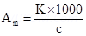  K= 0.0248 Scm⁻¹  c = 0.20 M  Therefore, Molar conductivity,  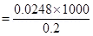
13 | i) The difference of energy between two sets of degenerated orbitals after crystal field splitting is known as crystal field splitting energy.  ii) Electronic configuration for d⁴ ion, if Δ₀​>P  t₂g⁴​eg⁰​
14 | Given I=1.50A , W= 1.50g , M = 108 , F=96500C t= ?  We know = W= Z x I x t  t= W/Z x I  = 1.50 x 96500 /108 x 1.50 = 893.51s  OR  (i) The electrode reaction is Al³⁺ + 3e ——> Al  ∴ Quantity of charge required for reduction of 1 mol of Al³⁺=3F=3 x 96500C=289500C.  (ii) The electrode reaction is Cu²⁺ + 2e– ——–> Cu  ∴ Quantity of charge required for reduction of 1 mol of Cu²⁺=2F=2 x 96500=193000 C.  (iii) The electrode reaction is Mn04- ———-> Mn²⁺.  i.e., Mn⁷⁺ + 5e–——-> Mn²⁺.  ∴ Quantity of charge required = 5F =5 x 96500 C=4825000.
15 | 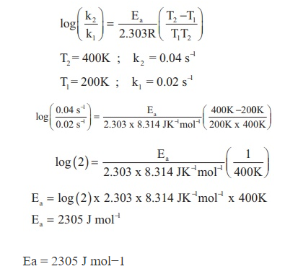
16 | i) OH⁻, Cl⁻ NH₃ or any other  OR  EDTA, en or any other  ii) Chelation is the formation of multiple coordination bonds between organic molecules and a transition metal ion leading to formation of cyclic complex.  iii) bidentate ligands may create two bonds with a central atom simultaneously, whereas ambidentate ligands can establish two bonds with a central atom but only one bond at once. eg- en is bidentate and SCN⁻ is ambidentate or any other.
17 | Formula: Ps = P_{A}⁰ x + P_{B}⁰ x  Case I: = and = 550 = + or (550 = + ) X 4, 2200 = 3 P_{A}⁰ + P_{B}⁰ eq 1  Case II:= and = 560 = + or (560 = +) X 5,  2800 = 4 P_{A}⁰ + P_{B}⁰ eq 2  Subtracting equation 1 from 2: 2800 = 4 P_{A}⁰ + P_{B}⁰  2200 = 3 P_{A}⁰ + P_{B}⁰  P_{A}⁰ = 600 mm Hg  Substituting P_{A}⁰ in equation 1 or 2  P_{B}⁰ = 400 mm Hg.  Ans (ii) In the solution of a gas in a liquid, one of the components is so volatile that it exists as a gas. Its solubility is given by Henry’s law. p = K_{H} x.  According to Raoult’s law: p= p₁º x  If we compare the equations for Raoult’s law and Henry’s law, it can be seen that the partial pressure of the volatile component or gas is directly proportional to its mole fraction in solution. Only the proportionality constant K_{H} differs from p₁⁰. Thus, Raoult’s law becomes a special case of Henry’s law in which K_{H} becomes equal to p₁⁰.  OR  Ans-(a)  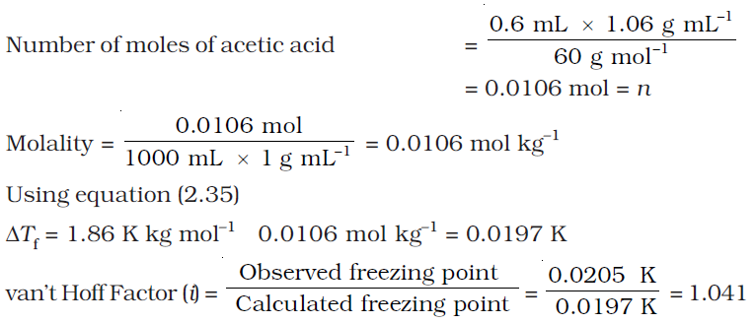  Ans (b) Osmotic pressure method is preferred for the determination of molar masses of macromolecules such as proteins and polymers because the magnitude of osmotic pressure is large even for very dilute solution and it can be measured at room temperature
18 | (a) 5Fe2+ (aq) + MnO4- (aq) + 8H+ (aq) → Mn²⁺ (aq) + 5Fe³⁺ (aq) + 4H₂O(l)  (b) Cr₂O₇²⁻ (aq) + 6I– (aq) + 14H+ (aq) → 2Cr³⁺(aq) + 3I₂ (s) + 7H₂O(l)  b) (i) Because of increase in effective nuclear charge and weak shielding effect of d electrons, the atomic radii decreases.  (ii) The E°_{M}²⁺/M for any metal is related to the sum of the enthalpy changes taking place in the following steps :  M(g) + Δ_{a}H → M(g) (Δ_{a}H = enthalpy of atomization)  M(g) + Δ_{i}H → M²⁺(g) (Δ_{i}H = ionization enthalpy)  M²⁺(g) + aq → M²⁺(aq) + Δ_{hyd}H (Δ_{hyd}H = hydration enthalpy)  Copper has high enthalpy of atomization (i.e. energy absorbed and low enthalpy of hydration (i.e. energy released). Hence E°_{M}²⁺/M for copper is positive. The high energy required to transform Cu(s) to Cu²⁺(aq) is not balanced by its hydration enthalpy.  (iii) The large positive E° value for Mn³⁺ | Mn²⁺ shows that Mn²⁺ is much more stable than Mn³⁺ due to stable half-filled configuration (3d⁵). Therefore the 3rd ionization energy of Mn will be very high and Mn³⁺ is unstable and can be easily reduced to Mn²⁺. E° value for Fe³⁺ | Fe²⁺ is positive but small i.e. Fe³⁺ can also be reduced to Fe²⁺ but less easily. Thus Fe³⁺ is more stable than Mn³⁺  OR  (a) This is because transition elements have strong metallic bonds as they have large number of unpaired electrons, therefore they have greater interatomic overlap  (b)The catalytic activity of transition metals is attributed to the following reasonsi)  Because of their variable oxidation state, transition metals form unstable intermediate compounds and provide a new path with lower activation energy for the reaction.  ii) In some cases, the transitions metal provides a suitable large surface area with free valencies on which reactants are adsorbed  (c) E°(M²⁺/M) values are not regular in the first transition series metals because of irregular variation of ionization enthalpies (IE₁ + IE₂) and the sublimation energies.  (d) ) Among transition elements, the bonds formed in +2 and +3 oxidation states are mostly ionic. The compounds formed in higher oxidation states are generally formed by sharing of d-electrons. Therefore, Mn can form MnO₄- which has multiple bonds also, while fluorine cannot form multiple bonds.  (e) The absence of unpaired d-electron in Sc³⁺ whereas in Ti³⁺ there is one unpaired electron or Ti³⁺ shows the d-d transition.
PRACTICE PAPER BOOK 1 SET-06
BLUE PRINT

.
S.No. | Name of Chapter | MCQ | A/R | SA1 | SA2 | Case Base | LA | Total
S.No. | Name of Chapter | 1 mark | 1 Mark | 2 Marks | 3 marks | 4 Marks | 5 marks
1 | Solutions |  | 2(2) | 2(1) | 3(1) |  |  | 7(4)
2 | Electrochemistry |  | 2(2) | 2(1) |  |  | 5(1) | 9(4)
3 | Chemical Kinetics | 2(2) |  | 2(1) | 3(1) |  |  | 7(4)
4 | d and f Block Elements | 2(2) |  |  |  |  | 5(1) | 7(3)
5 | Coordination Compounds | 2(2) |  | 2(1) | 3(1) |  |  | 7(4)
 | Total | 6(6) | 4(4) | 8(4) | 9(3) |  | 10(2) | 37 (19)

Set 06
Practice Paper BOOK 1 (2023-24)
MM:37 CHEMISTRY THEORY (043) Time: 1 ½ hours

Q.N. | Question | Marks
SECTION A
The following questions are multiple -choice questions with one correct answer. Each question carries 1 mark. There is no internal choice in this section.
1. | Which of the following observations is incorrect about the order of a reaction?  (a)Order of a reaction is always a whole number  (b)The stoichiometric coefficient of the reactants doesn’t affect the order  (c)Order of reaction is the sum of power to express the rate of reaction to the concentration terms of the reactants.  (d)Order can only be assessed experimentally | 1
2. | A catalyst alters, which of the following in a chemical reaction?  (a)Entropy (b)Enthalpy  (c)Activation energy (d)Internal Energy | 1
3. | The Cu²⁺ oxidation state is more stable than Cu⁺ while Cu²⁺ has d⁹ electric configuration due to  (a) High stability of d⁹ electronic configuration  (b) Low enthalpy of atomization  (c) High Hydration enthalpy  (d) Large value of d¹⁰ | 1
4. | The Eº value of Sc³⁺/Sc²⁺ is lower than Sc²⁺/ Sc¹⁺ because-  (a) Sc²⁺ has d¹ electronic configuration  (b) Sc³⁺ has Ar Noble gas electronic configuration  (c) Sc is first element of 3d series  (d) Eº value Sc²⁺/ Sc¹⁺ is greater | 1
5. | Which of the following ligands is not a chelating agent –  (a) EDTA (b) en  (c) Oxalate (d) Nitrito-N | 1
6. | Which one of the followings is central metal in Wilkinson catalyst-  (a) Pt (b) Au  (c) Rh (d) Co | 1
ASSERTION REASON TYPE QUESTIONS
In the following questions, two statements are given—one labelled Assertion (A) and the other labelled Reason (R). Select the correct answer to these questions from the codes (a), (b), (c) and (d) as given below:
(a) Both Assertion (A) and Reason (R) are correct statements, and Reason (R) is the correct explanation of the Assertion (A).
(b) Both Assertion (A) and Reason (R) are correct statements, but Reason (R) is not the correct explanation of the Assertion (A).
(c) Assertion (A) is correct, but Reason (R) is incorrect statement.
(d) Assertion (A) is incorrect, but Reason (R) is correct statement.
7 | Assertion (A) : The boiling point of 0.1 M urea solution is less than that of 0.1 M KCl solution.  Reason (R) : Elevation of boiling point is directly proportional to the number of species present in the solution. | 1
8 | Assertion (A) : Ethyl alcohol - water mixture is known as minimum boiling azeotrope.  Reason (R) : The solution which show a negative deviation from Raoult’s law form minimum boiling azeotrope | 1
9 | Assertion (A) : HCl can be kept in copper container but not in zinc container.  Reason (R): Hydrogen is more reactive than silver. | 1
10 | Assertion : For a cell reaction Zn(s) + Cu²⁺(aq) → Zn²⁺(aq) + Cu(s) : at the equilibrium, voltmeter gives zero reading.  Reason: At the equilibrium, there is no change in the concentration of Cu²⁺ and Zn²⁺ ion. | 1
SECTION B
This section contains 5 questions with internal choice in one question. The following questions are very short answer type and carry 2 marks each.

11 | Give reason-  (a) The tank used by scuba divers are filled with air diluted with helium.  (b) Climbers feel weakness and discomfort in breathing at hight altitude. | 2
12 | How does conductivity and molar conductivity vary with concentration? Give reasons for their variations.  OR  What are fuel cells? List any two advantages of fuel cells over other cells. | 2
13 | 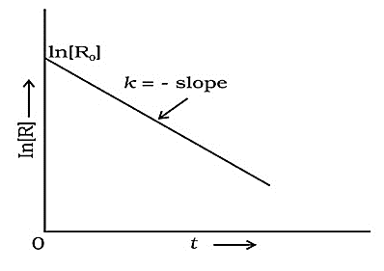  Observe the given curve and answer the followings –  (i) Find out order of reaction & unit of rate constant  (ii) Write the integrated rate equation for the reaction | 2
14 | For the following complex –  [Cr(NH₃)₂Cl₂(en)]⁺  (i) IUPAC name of the complex  (ii) Coordination number and oxidation state of Cr | 2
SECTION C
This section contains 7 questions with internal choice in one question. The following questions are short answer type and carry 3 marks each.
15 | A 5% solution (by mass) of cane sugar (M= 342 g/mol) in water has freezing point of 271 K. Calculate the freezing point of 5% glucose in water if freezing point of pure water is 273.15 K. | 3
16 | A first-order reaction takes 69.3 min for 50% completion. What is the time needed for 80% of the reaction to get completed?  (Given: log 5 =0.6990, log 8 = 0.9030, log 2 = 0.3010) | 3
17 | (a) Write the formula of the following coordination compound: Iron(III)hexacyanoferrate(II).  (b) What type of isomerism is exhibited by the complex [Co(NH₃)₅Cl]SO₄?  (c) Write the hybridisation and number of unpaired electrons in the complex [CoF₆]³⁻.(Atomic Number of Co =27)  OR  What is meant by crystal field splitting energy? On the basis of crystal field theory, write the electronic configuration of d₄ in terms of t₂g and eg in an octahedral field when -  (i) Δ⁰ > P (ii) Δ⁰ < P | 3
SECTION D
The following questions are long answer type and carry 5 marks each. All questions have an internal choice.
18 | Explain any five from the followings:  a) Zn, Cd, Hg are d block elements but not transition elements. why?  b) Why Cr⁺² is reducing and Mn⁺³ is oxidizing while both have d⁴ electronic configuration?  c) Calculate the magnetic momentum of a di-valent ion in aqueous solution if its atomic number is 25.  d) Why does ₄₀Zr has almost equal size to the ₇₂Hf ?  e) Why are d block elements are used as catalyst?  f) Transition metals form coloured compounds.  g) Sc⁺³ is colourless in aqueous solution where Ti⁺³ is coloured. Why?. | 5
19 | i) $λ_{m}^{ο}$ for NaCl, HCl, and CH₃COONa are 126.4, 426.9 and 91.0 S cm² mol⁻¹ respectively. Calculate $λ^{ο}$ for CH₃COOH.  ii) The cunductivity of 0.001028 mol/L acetic acid is $4.95 ×{10}^{-5} S cm^{-1}$. Calclute its dissocition constant if $Λ_{m}^{ο}$ for acetic acid is $390.5 S {cm }^{2} {mol}^{-1}.$  OR  The following curve is obtained when molar conductivity, Λ_{m} is plotted against the square root of concentration, C^{1/2} along y and x-axis respectively for the two electrolytes X and Y.  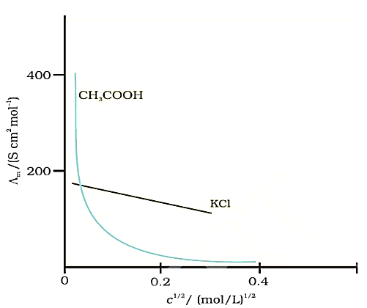  Y = CH₃COOH  X= KCl  i) What do you know about the nature of these two electrolytes?  ii) How do you account for the increase in Λ _{m} for the electrolytes X and Y with dilution?  iii) How can you determine $Λ_{m}^{o}$ for these electrolytes? | 5
S.N. | Answer | Marks
   | PRACTICE PAPER BOOK 1 SET 06
  Q | 1 | 2 | 3 | 4 | 5 | 6 | 7 | 8 | 9 | 10
  Ans | A | C | C | B | D | C | A | C | B | A
11 | (a) to avoid bends as well as the toxic effects of hight concentration of nitrogen in the blood.  (b) Due to low concentration of oxygen in the blood because of low partial pressure of oxygen at high altitude. | 1+1
12 | Conductivity decreases with the decrease in concentration, this is because the number of ions per unit volume that carry the current in the solution decreases on dilution.  Molar conductivity increases with the decrease in concentration or increase in dilution. This is because the total volume of solution containing one mole of electrolyte increases with increase in dilution. It has been found that the decrease in 𝜅 on dilution of a solution is more than compensated by increase in its volume.  OR  Fuel Cells : Fuel cell is a device which converts the energy of combustion of fuels such as H₂, CO, CH₄ etc. directly into electrical energy.  Advantages : i) High efficiency ii) Continuous source of energy iii) Pollution free working. | 2
13 | (i) first order , unit is sec⁻¹  (ii) k = $\frac{2.303}{t}$ log $\frac{[R]o}{[R]}$ | 2
14 | (i) diamminedichlorido(ethane-1,2-diamine)chromium(III) ion  (ii) Coordination Number – 6, Oxidation state of Cr- +3 | 1+1/2+1/2
15 | Mass of sugar in 5% (by mass) solution means 5g in 100g of solvent (water)  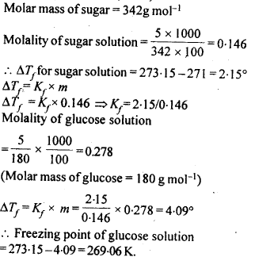 | 3
16 | 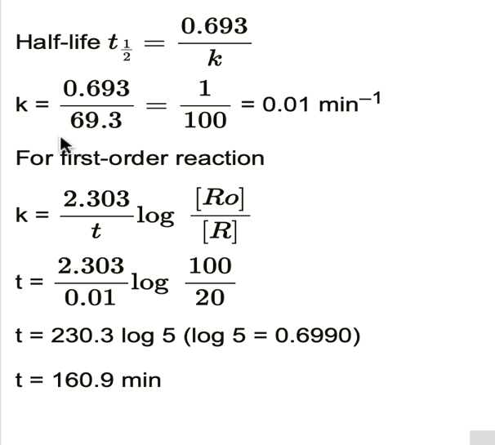 | 1+1+1
17 | (a) Fe₄[Fe(CN)₆]₃  (b) Ionisation isomerism. Its ionisation isomer will be [Co(NH₃)₅(SO₄)]Cl.  (c) Hybridisation – sp³d², number of unpaired electron = 4.  OR  The difference between energies of two sets of d-orbitals t₂g and eg is called crystal field splitting energy (Δ₀).  If Δ₀ > P, the configuration will be t₂g4, eg0. Ligands will produce strong field and pairing takes place. If Δ0 < P, the configuration will be t₂g3, eg1 and it is in the case of weak field ligands and pairing will not take place. | 1+1+1
18 | (a) Transition metals are defined as the elements having incompletely filled d orbitals. Since Zn, Cd and Hg have completely filled d orbital, they are not regarded as transition elements.  (b) the change from Mn3+ to Mn2+ results in the half-filled (d5) configuration which has extra stability. That is why Cr2+ is reducing and Mn3+ is oxidising when both have d4 configuration.  (c) The divalent ion in aqueous solution will have d5d5 configuration (five unpaired electrons) with atomic number 25. The magnetic moment, µ is: μ= $\sqrt{5\left(5+2\right)}$= 5. 92BM.  (d) Zr and Hf have almost identical atomic radii due to lanthanoid contraction. Hf is post lanthanoid element. As a result of lanthanoid contraction, the atomic size of Hf is similar to Zr (element of previous period).  (e) Due to variable oxidation state, vacant d orbital and tendency to form complex.  (f) Due to d-d transition of unpaired electrons  (g) Due to absence of unpaired electron Sc³⁺ is colourless and due to presence of one unpaired electron, d−d transition take place hence Ti³⁺ is coloured.
19 | 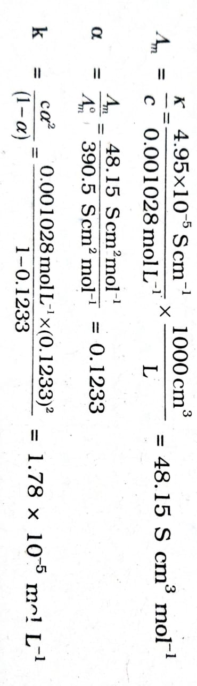  i)  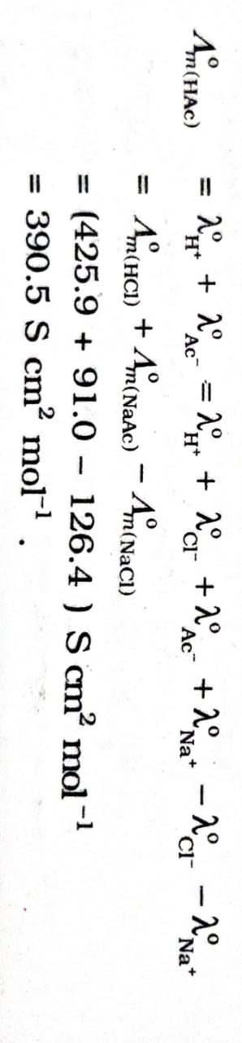  ii)  OR  i. Electrolyte X is a strong electrolyte and Y is a weak electrolyte.  ii. Molar conductivity, Λ_{m} of X (strong electrolyte ) increases slowly with dilution. This is because interionic forces of attraction decreases on dilution, although the number of ions remain the same. As a result ions move freely and hence Λ_{m} increases with dilution. On the other hand, for Y (weak electrolyte) Λm increases sharply with dilution. This is because degree of dissociation increases on dilution resulting in greater number of ions on dilution. Hence Λ_{m} increases.  iii. For X electrolyte Λ∞ can be obtained by extrapolation to zero concentration. For Y electrolyte Λ∞ can be obtained by using Kohlrausch Law of independent migration of ions.

PRACTICE PAPER BOOK 1 SET 7 (2023-2024)
Chapter | MCQ (1M) | R-A (1M) | VSA (2M) | SA (3M) | CASE BASED (4M) | LONG ANS (5M) | TOTAL MARKS
1. SOLUTION | 1 (1) |  |  | 6(2) |  |  | 7(3)
2. ELECTROCHEMISTRY | 2(2) | 2 (2) | 2(1) | 3(1) |  |  | 9(6)
3. CHEMICAL KINETICS |  | 2 (2) |  |  |  | 5 (1) | 7(3)
4. D-AND-F BLOCK ELEMENTS | 2 (2) |  | 2 (1) | 3(1) |  |  | 7(4)
5. COORDINATION COMPOUNDS |  |  | 2 (1) |  |  | 5(1) | 7(2)
TOTAL QUESTIONS | 5 (5) | 4 (4) | 6(3) | 12(4) |  | 10 (2) | 37(18)

Set 07
Practice Paper BOOK 1 (2023-24)
MM:37 CHEMISTRY THEORY (043) Time: 1 ½ hours
SECTION A
The following questions are multiple -choice questions with one correct answer. Each question carries 1 mark. There is no internal choice in this section.

- Which of the following solutions will have the highest boiling point?
(a) 0.1 M NaCl solution (b) 0.1 M Glucose solution
(c) 0.1 M CH₃COOH solution (d) 0.1 M Sucrose solution
- Which of the statements about solution of electrolyte is not correct?
(a) Conductivity of solution depends upon size of ions
(b) Conductivity of solution depends upon viscosity of solution
(c) Conductivity does not depends upon solvation of ions present in solution
(d) Conductivity of solution increases with temperature.
- Which of the following is correct for spontaneity of a cell?
(a) ∆G= - ve, E⁰ = + ve (b) ∆G= + ve, E⁰ = + ve
(c) ∆G= + ve, E⁰ = - ve (d) ∆G= - ve, E⁰ = - ve
- The spin only magnetic moment of Cr³⁺ ion is
(a) 2.87 B. M. (b) 3.87 B. M.
(c) 3.47 B. M. (d) 3.57 B. M.
- Which of the following is the reason for Zinc not exhibiting transitional properties?
(a) Inert Pair effect (b) Completely filled 3d subshell
(c) Larger size (d) Common ion effect
Given below are two statements labelled as Assertion (A) and Reason (R)
Select the most appropriate answer from the options given below:
(a) Both A and R are true and R is the correct explanation of A
(b) Both A and R are true but R is not the correct explanation of A.
(c) A is true but R is false.
(d) A is false but R is true.
- Assertion (A): Mercury cell does not give steady potential.
Reason (R): In the cell reaction, ions are not involved in solution.
- Assertion (A): Electrolysis of NaCl solution gives Chlorine at anode instead of oxygen.
Reason (R): Production of oxygen at anode require overvoltage/over potential.
- Assertion (A): Hydrolysis of an ester follows first order kinetics.
Reason (R): Concentration of water remains nearly constant during the course of the reaction as it is taken in excess.
- Assertion (A): Order of the reaction can be zero or fractional
Reason (R): Order of a chemical reaction cannot be determined from balanced chemical equation.
SECTION B
This section contains 5 questions with internal choice in one question. The following questions are very short answer type and carry 2 marks each.
- Name the cell which
(a) was used in Apollo space programme.
(b) is suitable for hearing aid and watches.
(c) is used in automobiles and inverters.
(d) is used in transistors.
- Complete the following chemical equations
(a) MnO₄⁻ + S₂O₃²⁻ + H₂O
(b) Cr₂O₇²⁻ + Sn²⁺ + H⁺
- (a) What type of isomerism is shown by the complex [Cr (H₂O)₆]Cl₃ ?
(b)On the basis of CFT , write the electronic configuration for d⁴ ion if Δ₀ > P .
Or
(a) Using IUPAC norms write the systematic name of the [Co(en)₃]³⁺
(b) Draw the structures of optical isomers of: [Cr(C₂O₄)₃]^{3–}

SECTION C
This section contains 7 questions with internal choice in one question. The following questions are short answer type and carry 3 marks each
- An aqueous solution freezes at 272.4 K while pure water freezes at 273 K. Determine (i) Molality of solution. (ii) Boiling point of solution
Given: K_{f} = 1.86 K Kg mol⁻¹ , K_{b} = 0.512 K Kg Mol⁻¹ )

- Give reasons
(a) Measurement of osmotic pressure method is preferred for the determination of molar masses
of Macromolecules such as proteins and polymers.
(b) Aquatic animals are more comfortable in cold water than in warm water.
(c) Red blood cells shrink when placed in saline water but swell in distilled water.

- Calculate the emf of the cell in which the following reaction takes place:
Given that E⁰ _{cell} =1.05 V

- Accounts for the following
(a)Cu ²⁺ salts are coloured while Zn ²⁺ are white.
(b) E⁰ value for the Mn ³⁺/ Mn²⁺ couple is much more positive than that for Cr³⁺/Cr²⁺ .
(c) There is a gradual decrease in the size of atoms with increasing atomic number in the series of
Lanthanoids
Or

Describe the preparation of potassium permanganate. How does the acidified permanganate solution react with oxalic acid? Write the ionic equations for the reactions.

SECTION D
The following questions are long answer type and carry 5 marks each. All questions have an internal choice
- (a) For the reaction at 500K,
NO₂ (g) + CO (g)→CO₂ (g) + NO (g)
The proposed mechanism is as below:
Step 1: NO₂ + NO₂→NO + NO₃ (slow)
Step 2: NO₃+ CO→CO₂ + NO₂ (fast)
What is the rate law for the reaction?
(b) The decomposition of NH₃ on platinum surface is a zero order reaction. What are the rates of
production of N₂ and H₂ if k 2.5 x10⁻⁴molL⁻¹s⁻¹?
(c)A reaction is first order with respect to A and second order with respect to B. How will be the rate affected when the Concentration of both A and B is doubled?
- From the rate expression of the given reaction, CH₃CHO (g)→CH₄ (g) + CO (g)
Rate = k [CH₃CHO]^{3/2}
Determine the unit of rate constant
Or
(a) Differentiate between Rate of reaction and reaction rate constant.
(b) The first order rate constant for the decomposition of ethyl iodide by the reaction
C₂H₅I (g) → C₂H₄ (g) + HI (g)
at 600K is 1.60 × 10^{–5} s^{–1} and its energy of activation is 209 kJ/mol. Calculate the log K
of the reaction at 700K. (Given : Log 1.6 = 0.2041 )

- (a) Compare the following properties of complexes [Fe(CN)₆]⁴⁻ and [FeF₆]³⁻ on the basis of VBT-
(i) Geometry (ii) magnetic nature (iii) Colour properties
(b) Define the following terms:
(i) Ambident ligands (ii) Chelation

Or
- [NiCl₄]²⁻ is paramagnetic while [Ni(CO)₄] is diamagnetic though both are tetrahedral ,why ?
- Using Valence bond theory, explain the following in relation to the paramagnetic complex [Mn(CN)₆)³⁻]
(i)type of hybridization
(ii) magnetic moment value
(iii) type of complex – inner, outer orbital complex

PRACTICE PAPER BOOK 1 Marking Scheme SET-07 (2023-24)
1 | 2 | 3 | 4 | 5 | 6 | 7 | 8 | 9
a | c | A | b | b | d | a | a | B

10.(a) Fuel Cell (b) Mercury cell (c) Lead storage battery (d) Dry cell (1/2*4=2)
11. (a) 8MnO₄⁻ + 3S₂O₃²⁻ + H₂O 8MnO₂ + 6SO₄²⁻ +2OH⁻ (1+1=2)
(b) Cr₂O₇²⁻ + 3Sn²⁺ + 14 H⁺ 2Cr³⁺ + 3Sn⁴⁺ + 7 H₂O
12. (a) Hydrate isomerism. (1)
(b) Δ₀ > P so t2g⁴ e_{g}⁰ (1)
Or
- Tris(ethan-1,2-diammine)cobalt(III) ion (1)

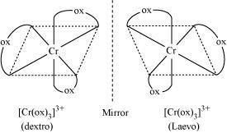 (1)

13. (i) ΔT_{f} ₌ K_{f}  m Therefore m = ΔT_{f} / K_{f} = 0.6/1.86 = 0.32mol / Kg (1)

(ii) ΔT_{b} ₌ K_{b}  m = 0.512 x 0.32 = 0.164 Therefore T_{b} = 373 + 0.164 = 373.16 K (1)
(iii) ∆P = P⁰.m.M_{A}= 23.756 x 0.32 x 0.018 = 0.137 mm Hg. (1)
14. (a) The osmotic pressure can be measured at room temperature and its magnitude is large even for very dilute solution. (1)
(b) At higher temperature the solubility of oxygen get decreased in water (1)
(c) Because exosmosis will occur when kept saline water while endosmosis will occur when kept in
distilled water. (1)
15. Applying Nernst equation we have:
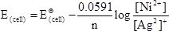 ½
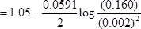 ½
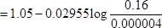 ½
= 1.05 – 0.02955 log 4 x 10⁴ ½
= 1.05 – 0.02955 (log 4+ 4log 10) ½
= 1.05 – 0.02955 ( 0.6021 + 4)
= 0.914 V ½
16 (a) Cu²⁺ have unpaired electron while Zn²⁺ does not have unpaired electron (1)
(b) The large positive E° value for Mn³⁺/Mn²⁺ shows that Mn²⁺ is much more stable than Mn⁺³ due to stable half-filled configuration (3d⁵). Therefore the 3rd ionisation energy of Mn will be very high
and Mn³⁺ is unstable and can be easily reduced to Mn²⁺. E° value for Cr³⁺ | Cr²⁺ is positive but small i.e. Cr³⁺ can also be reduced to Cr²⁺ but less easily. Thus Cr³⁺ is more stable than Mn³⁺. (1)
(c) This is due to lanthanoid contraction. (1)
Or
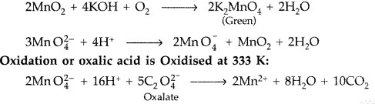 ( 2 +1)
17. (a) k [NO₂]² (1)
(b) d[N₂]/dt = 2.5 x10⁻⁴molL⁻¹s⁻¹
d[H₂]/dt =3x 2.5 x10⁻⁴molL⁻¹s⁻¹ (2)
(c) r₁ = k[A]¹[B]²
r2 = k [2A] [2B] ² = 8 r1 (8 times) (1)
- Unit of K = L1/2mol-1/2s-1 (1)
OR

Rate of reaction | Rate constant (K)
1. Change in concentration of any one of the reactants/products per unit time.  2. It is dependent on the initial concentrations of the reactant.  3. Unit: mol L-1s^{–1} or atm s^{–1}. | 1. Rate constant when concentrations of all reactants are unity.  2. It is independent of the initial concentrations of the reactant.  3.Unit: depends on the order of reaction.
(2)
- We know that
log k₂ – log k₁ = E_{a}/2.303R[1/T₁ − 1/T₂ ] ½
log k₂ = log k₁ + E_{a}/2.303R[1/T₁ − 1/T₂]
= log (1.60 × 10⁻⁵) + 209000 J mol L⁻¹/2.303 × 8.314 J mol L⁻¹K⁻¹ [1/600K − 1/700K] ½
log k₂ = – 4.796 + 2.599 = – 2.197 2

18. (a) 1x3=3
Properties | [Fe(CN)₆]⁴⁻ | [FeF₆]³⁻
Geometry | Octahedral | Octahedral
Magnetic property | Diamagnetic | Paramagnetic
Colour property | Colourless | Coloured
(b) (i) Ambident ligand: Ligands which have two donar atoms but donates only one of them at a time to central metal ion. Eg. SCN⁻ CN⁻ (1)
(ii) Chelation: Phenomenon in which a bidentate/ polydentate ligand forms cyclic complex to enhance stability of the complex is called chelation. EDTA (1)
Or
(a) In[NiCl₄]²⁻, Ni is +2 oxidation state with the configuration 3d⁸4S⁰ ,Cl⁻ is weak ligand . it cannot pair up the electron in 3d orbitals , Hence it is paramagnetic .In [NI(CO)₄,Ni is in zero oxidation state with the configuration 3d⁸4s²,In the presence of CO ligand , the 4s electrons shift to 3d to pair up 3d electron s .thus ,there is no unpaired electron present . Hence it is diamagnetic. (2)
(b) (i) d²sp³ (1)
(ii) 2.83 B.M. (1)
(iii) Inner orbital complex (1)

PRACTICE PAPER BOOK 1 SET 8
BLUE PRINT
CHAPTER NAME | MCQ  (1 M) | AR  (1M) | SA-1  (2 M) | SA-2  (3M) | CBQ  (4M) | LAQ  (5M) | TOTAL
SOLUTION | 2(2) |  |  |  |  | 5(1) | 7(3)
ELECTROCHEMISTRY | 3(3) |  | 2(1) |  | 4(1) |  | 9(5)
CHEMICAL KINETICS |  | 2(2) | 2(1) | 3(1) |  |  | 7(4)
D AND F BLOCK ELEMENTS |  | 2(2) |  |  |  | 5(1) | 7(3)
COORDINATION COMPOUNDS | 1(1) |  |  | 6(2) |  |  | 7(3)
TOTAL | 6(6) | 4(4) | 4(2) | 9(3) | 4(1) | 10(2) | 37(18)

Set 08
Practice Paper BOOK 1 (2023-24)
MM:37 CHEMISTRY THEORY (043) Time: 1 ½ hours
SECTION A
- Which of the following is not a colligative property
(a) Relative lowering of vapour pressure (b) Depression in freezing point
(c) osmotic pressure (d) lowering of vapour pressure
- Which one of the following pairs will form an ideal solution
(a) Chloroform and acetone (b) Ethanol and acetone
(c) ) n- hexane and n-heptane (d) Phenol and aniline
- The geometry of complex Ni(CO)₄ is:
(a)Square plane (b) Tetrahedral (c)Octahedral (d)Trigonal planar
- The conductivity is measured in
(a)Ohm⁻¹cm⁻¹ (b) Ohmcm⁻¹ (c) Ohm⁻¹cm (d) Ohm⁻¹cm²mol⁻¹
- In a lead storage battery
(a)PbO₂ is reduced to PbSO₄ at the cathode
(b) Pb is oxidised to PbSO₄ at the anode
(c ) Both electrodes are immersed in the same aqueous solution of H₂SO₄
(d) All the above are true
- The molar conductivity of a 0.5 mol dm⁻³ solution of AgNO₃ with electrolytic conductivity of 5.76X 10⁻³ Scm⁻³ at 298 K in Scm²mol⁻¹ is
(a) 2.88 (b)11.52 (c ) 0.086 (d) 28.8

In the following questions (Q. No. 13 - 16) a statement of assertion followed by a statement of reason is given. Choose the correct answer out of the following choices.
- Assertion and reason both are correct statements and reason is correct explanation for assertion.
- Assertion and reason both are correct statements but reason is not correct explanation for assertion.
- Assertion is correct statement but reason is wrong statement.
- Assertion is wrong statement but reason is correct statement.
- Assertion (A): Hydrolysis of an ester follows first order kinetics
Reason(R): Concentration of water remains constant during the course of the reaction.
- Assertion (A) : Actinoids show larger number of oxidation states than lanthanoids .
Reason(R): Lanthanoids show highest +4 oxidation state while actinoids shows +7 .
- Assertion (A) : Order and molecularity are same .
Reason(R): Order is determined experimentally and molecularity is the sum of the stoichiometric coefficient of the rate determining elementary step.
- Assertion(A): Cu+ ion is not stable in aqueous solution.
Reason(R): Cu+ contains 3d fully filled subshell.
SECTION B
The following questions, Q.No 17 – 21 are short answer type and carry 2 marks each.
- A first order reactions has a rate constant 1.15 x 10⁻³ s⁻¹.How long will 5 g of this reactant take to reduce to 3 g?
OR
A first order reaction takes 40 min for 30% decomposition. Calculate t₁/₂
- ∧∘_{m} for NaCl, HCl and NaAc are 126.4, 425.9 and 91.0 Scm²mol⁻¹ respectively. Calculate ∧∘m for HAc.
SECTION C

- Write the hybridisation and magnetic character of the following complexes:
(i) [Ni(CN)₄]⁻² (ii)[CoF₆]³⁻ (iii) [Fe(H₂O)₆]²⁺
- Write the IUPAC name of complex [Pt(en)₂Cl₂]. Draw the structures of geometrical isomers for this complex.
OR
Draw the structural formula of two isomers of the complex ion [Co(NH₃)₅NO₂]^{2+.} Name the type of isomerism and give their IUPAC names .
- (i) Show that in a first order reaction, time required for completion of 99.9% is 10 times of half-life (t_{1/2}) of the reaction.
(ii) Plot a graph between log [R]₀/[R] vs time for a first order reaction and find the slope of the curve.
SECTION D
- Read the passage carefully and answer the questions:
Redox reactions play an important role in chemistry. Whenever a redox reaction takes place directly in a single beaker, chemical energy in the form of heat is produced. By suitable means, it is possible to bring about the redox reactions indirectly so as to convert the chemical energy into electrical energy. A device used to convert the chemical energy produced in a redox reaction into electrical energy is called an electrochemical cell. If a redox reaction is allowed to take place in such a way that oxidation half reaction takes place in one beaker and the reduction half reaction in another beaker, the electrons given out by the former will be taken by the latter and the current will flow. The two portions of the cell are called half cells. The values of standard redox potential (Eº) of two half cell reactions decides in which way the reaction will proceed. A redox reaction is feasible when the substance having higher reduction potential gets reduced and the one having lower reduction potential gets oxidised. For example, in Daniel cell, zinc goes into solution and copper gets deposited.
- Formulate the galvanic cell for the reaction :
Zn(s) + 2Ag⁺¹ (aq) → Zn²⁺ (aq) + 2Ag(s)
OR
In Daniel cell, which electrode works as anode and which one as cathode?
- Is it safe to stir AgNO₃ solution with a copper spoon? Why or why not?
Given: Eº_{Ag+/Ag}= 0.80 volt and Eº_{Cu2+/Cu}= + 0.34 volt
- Two half-cell reactions of an electrochemical cell are given below.
MnO₄⁻(aq) +8H⁺ (aq) + 5e⁻→ Mn²⁺(aq) + 4H₂0(l), E°= +1.51 V
Sn²⁺(aq) -- Sn⁴⁺(aq) + 2e⁻, E° = +0.15 V

Construct the redox reaction from the above two half-cell reactions and predict if this reaction favours formation of reactants or products shown in the equation.
OR
- (i) State the factors affecting cell potential of: Mg(s) / Mg²⁺ (aq) || Ag+ (aq) /Ag(s)
(ii) Can E°_{cell} for cell reaction ever be equal to zero?
SECTION-E
- Answer any five questions:
- Which of 1.0 M aqueous glucose solution and 1.0 M NaCl aqueous solution has higher boiling point and why?
- Arrange following aq. Solutions in increasing order of their freezing points.
(i)0.1 M NaCl (ii) 0.1 M CaCl₂ (iii) 0.1 M CH₃COOH (iv) 0.1 M urea
- Name the colligative property that is best for determining molecular masses of macromolecules? Also give reason for the same.
- Two aqueous solutions (A) 0.1M FeCl₃ and (B) 0.2M KCNS are separated by a semipermeable membrane. To which side will the formation of blood red colour be noticed? Why?
- Why is ethylene glycol mixed with water in the car radiators in cold countries?
- Which of the solutions below given has:
(1) Lowest vapour pressure? (2) Highest osmotic pressure
(A)0.1 M NaNO₃ (B) 0.1 M MgCl₂
(C) 0.1 M CH₃COOH (D) 0.1 M Glucose
- (A) Give reason for the following observations:
(i) Transition metals show catalytic properties
(ii) Transition metals form coloured complexes
(iii) With d⁴ configuration Cr²⁺ is reducing agent but Mn³⁺ is oxidizing agent. Why?
(B) A black coloured manganese compound (X) on heating with KOH in air produces a green coloured compound (Y). On adding O₃ to aqueous solution of (Y) another manganese compound (Z) of purple coloured is formed.
(i) Identify (Y) and (Z)
(ii) Write balanced chemical equation of conversion of (Y) to (Z) in the presence of
ozone.

OR
- Complete following reactions:
- MnO₄⁻¹ + Fe²⁺ + H⁺¹ ----------
Basic Medium
- MnO₄⁻¹ + Br¹⁻ --------------------------

- Give reason for the following:
- Name the transition metal is that strongest oxidizing agent in +3 oxidation state among all 3d- transition metals.
- Cu⁺¹ compounds undergo disproportion in aqueous medium.

Practice paper book 1 set 8
Q.NO. | 1 | 2 | 3 | 4 | 5 | 6 | 7 | 8 | 9 | 10
ANS | D | C | B | B | A | D | A | C | D | B
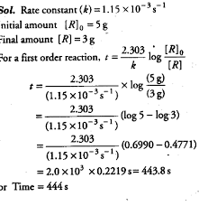
11.

OR
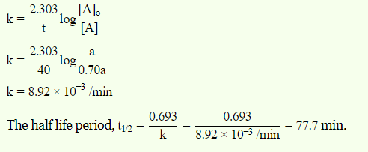
12. 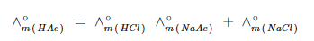
=425.9+ 91.0 -126.4 =390.5 Scm²mol⁻¹

13.(i) Tetracyanonickelate(II) (ii) Hexafluoridocobaltate(III)
(iii) Hexaaquairon(II)
14. Dichloridobis(ethane-1,2-diammine)platinum(II).
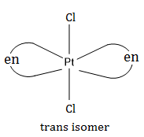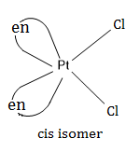
OR
[Co(NH₃)₅NO₂]²⁺ = pentaamminenitrocobalt(III) and [Co(NH₃)₅ONO]²⁺ pentaamminenitritocobalt(III) .
Linkage isomerism

15. (i)
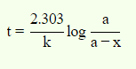 | 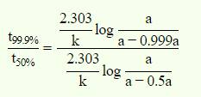

(ii)
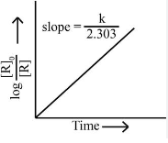
16.1)Ans. The cell is represented as: Zn(s) Zn²⁺(aq) || Ag⁺ (aq)|Ag(s)
OR
Zinc electrode as anode and copper electrode as cathode.
(2)Ans. No, because copper is more reactive than Ag and can displace Ag from AgNO₃,solution.
3)Ans. 2MnO₄⁻(aq) +16H⁺(aq) + 5Sn²⁺ → 2Mn²⁺ (aq) +5Sn⁴⁺ + 8H₂O(1)
Ecell = E_{Cathode} - E_{anode} = 1.51 V-0.15 V = 0.36 V, product forms
OR
Ans. (1) concentration of Mg2+ and Ag ⁺ ions in the solution and temperature.

- No. E⁰_{cell} for cell reaction can never be zero.
17. (a)Ans: 0.1 M NaCl as it has i=2 but glucose solution has i=1
And ΔT_{f} =i K_{f} m
(b)Ans: (ii)< (i)<(iii)<(iv)
(c) Ans: Osmotic pressure as it gives absolute value but other C.P. give relative values
(d)Ans: No red colour will appear at any side as only water will move through SPM and not ions.
(e)Ans: It reduces freezing point of water
(f)Ans: (i) lowest V.P. = B as it has highest number of particles of solute
(ii) Highest osmotic pressure = B as its i= 3 is highest

18 (A): (i)Ans: due to variable oxidation states
(ii) Ans: due to d-d transition
(iii)Ans: Cr²⁺ gets oxidized to Cr³⁺(t_{2g}³) that has stable electronic configuration
Mn²⁺ has stable d⁵ configuration that is half filled
(B) (i) X = MnO₂ Y = K₂MnO₄ Z= = KMnO₄

(ii) 2MnO₄⁻² + O₃ + H₂O --------------- O₂ + 2MnO₄⁻¹ S +2OH⁻¹

OR
(A)(i): MnO₄⁻¹ + 5Fe²⁺ + 8H⁺¹ ------------------ Mn²⁺ + 5Fe³⁺ + 8H₂O

(ii)2MnO₄⁻¹ + Br¹⁻ + H₂O ---------- 2MnO₂ + BrO₃⁻¹ + 2OH⁻¹

(B) (i)Ans: Co³⁺
(ii)Ans: Cu⁺² has high -VE value of enthalpy of hydration

PRACTICE PAPER BOOK 1 SET 09 BLUE PRINT
S.No. | Name of Chapter | MCQ | A/R | SA1 | SA2 | Case Base | LA | Total
S.No. | Name of Chapter | 1 mark | 1 Mark | 2 Mark | 3 mark | 4 Mark | 5 mark
1 | Solutions | 2(2) |  | 2(1) | 3(1) |  |  | 7(4)
2 | Electrochemistry | 1(1) |  |  | 3(1) |  | 5(1) | 9(3)
3 | Chemical Kinetics | 2(2) |  | 2(1) | 3(1) |  |  | 7(4)
4 | d and f Block Elements |  | 2(2) | 2(1) | 3(1) |  |  | 7(4)
5 | Coordination Compounds |  | 2(2) |  |  |  | 5(1) | 7(3)
 | Total | 5(5) | 4(4) | 6(3) | 12(4) |  | 10(2) | 37(18)
Note-With in bracket number of questions and outside bracket marks

Set 09
Practice Paper BOOK 1 (2023-24)
MM:37 CHEMISTRY THEORY (043) Time: 1 ½ hours
SECTION: A
- Value of henry constant K_{H}:
(a) increase with decrease in temperature (b) decrease with increase in temperature
(c) increase with increase temperature (d) remain constant
- If molarity of a dilute solution is doubled, the value of molal elevation costant(K_{b}) will be:
(a) halved (b) doubled (c) tripled (d) unchanged
- Molar conductivity of ionic solution depends upon ……………….
(a) temperature (b) distance b/w electrodes
(c) concentration of electrolytes in solution (d) both a and c
- If 50% of the reactant is converted into a product in a first order reaction in 25 minutes how much of it would treat in 100 minutes.
(a) 87.5% (b) 93.67% (c) 100% (d) 75%
- An endothermic reaction with high activation energy for the forward reaction is given by the diagram.
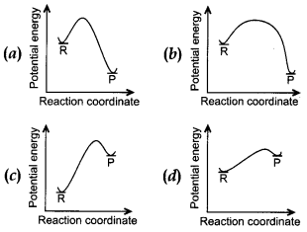
Directions: These questions consist of two statements, each printed as Assertion and Reason. While answering these questions, you are required to choose any one of the following four responses.
(a) If both Assertion and Reason are correct and the Reason is a correct explanation of the Assertion.
(b) If both Assertion and Reason are correct but Reason is not a correct explanation of the Assertion.
(c) If the Assertion is correct but Reason is incorrect.
(d) If the Assertion is incorrect and Reason is correct.
- Assertion: Cuprous ion (Cu⁺) has unpaired electrons while cupric ion (Cu²⁺) does not.
Reason: Cuprous ion (Cu⁺) is colorless whereas cupric ion (Cu⁺⁺) is blue in the aqueous solution.
- Assertion: Transition metals show variable valency.
Reason: Transition metals have a large energy difference between the ns² and (n – 1)d electrons.
- Assertion(A): Cr ²⁺ is reducing and Mn ³⁺ is oxidising.
Reason(R): Cr ³⁺ has d³ configuration and Mn ²⁺ have d⁵ configuration
- Assertion(A): In the series Sc to Zn, the enthalpy of atomisation of Zinc is the lowest.
Reason(R): Zinc has greater number of unpaired electrons.
SECTION B
- The rate constant for a first order reaction is 60 s ^{–1}. How much time will it take to reduce the initial concentration of the reactant to its 1/16th value?
- Account for the following
(a) Cu + ion is not stable in aqueous solutions
(b) Scandium is a transition element but Zinc is not.
- Vapour pressure of pure water at 298 K is 23.8 m m Hg. 50 g of urea (NH₂CONH₂) is dissolved in 850 g of water. Calculate the vapour pressure of water for this solution and its relative lowering.
section – c

- Complete the following chemical equations :
(i) MnO²⁻₄ (aq) + S₂O₃²⁻ (aq) + H₂O (1) →
(ii) Cr₂O₇²⁻ (aq) + Fe²⁺ (aq) + H⁺ (aq) →
(iii)Cr₂O₇²⁻ + H⁺ + I⁻ →
- A reaction is first order in A and second order in B.
(i) Write the differential rate equation.
(ii) How is the rate affected on increasing the concentration of B three times?
(iii) How is the rate affected when the concentrations of both A and B are doubled?
- The molar conductivity of 0.025 mol L⁻¹ methanoic acid is 46.1 S cm² mol⁻¹. Calculate its degree of dissociation and dissociation constant Given λ°(H⁺)=349.6 S cm² mol⁻¹ andλ°(HCOO-) = 54.6 S cm² mol⁻¹.
- Determine the osmotic pressure of a solution prepared by dissolving 25 mg of K₂SO₄ in 2 litre of water at 25°C, assuming that it is completely dissociated.
SECTION D
- Attempt any five of the following:
  - Indicate the types of isomerisms exhibited by the complex [Co(NH₃)₅ (NO₂)] (NO₃)₂.
  - What is meant by chelate effect?
  - Why are low spin tetrahedral complexes not formed?
  - [Fe(H₂O)₆]³⁺ is strongly paramagnetic whereas [Fe(CN)₆]³⁻ is weakly paramagnetic. Explain.
  - Explain why [Co(NH₃)₆]³⁺ is an inner orbital complex whereas [Ni(NH₃)₆]²⁺ is an outer orbital complex. (At. no. Co = 27, Ni = 28) ?
  - Write the IUPAC name of the complex [Cr(NH₃)₄Cl₂]⁺. What type of isomerism does it exhibit?
  - Write IUPAC name of the complex: [CoCl₂(en)₂]⁺
- (a) Calculate the standard cell potentials of the galvanic cells in which the following reactions take place.
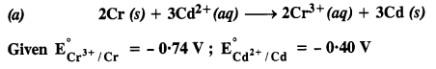
Also calculate ∆G° and equilibrium constant for the reaction.
(b) Write the chemistry of recharging the lead storage battery, highlighting all the materials that are involved during recharging.
OR
(a)Depict the galvanic cell in which the reaction
Zn(s) + 2Ag⁺(aq) —-> Zn²⁺(aq) + 2Ag (s) takes place. Further show:
(i) Which of the electrode is negatively charged?
(ii) The carriers of the current in the cell.
(iii) Individual reaction at each electrode.
(b) Explain Corrosion as an electrochemical process.

PRACTICE PAPER BOOK 1 SET -9(2023 -24)
MARKING SCHEME

Section A :
Q.1 C Q.2 D Q.3 D Q.4 B Q.5 C Q.6 D Q.7 C Q.8 A Q9. C
Section B
Ans10
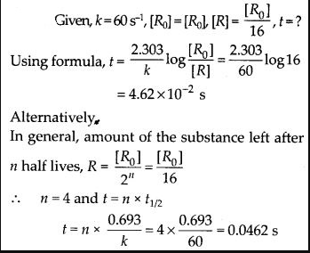

Ans11 (a) Cu + ion is not stable in aqueous solutions because large value of second ionization enthalpy of copper is compensate by much more negative hydration energy of Cu.
(b) On the basis of incompletely filled 3d- orbitals in case of Sc atom in ground state and Zn atom has completely filled of d-orbital. Its regarded as a transition element
Ans12.
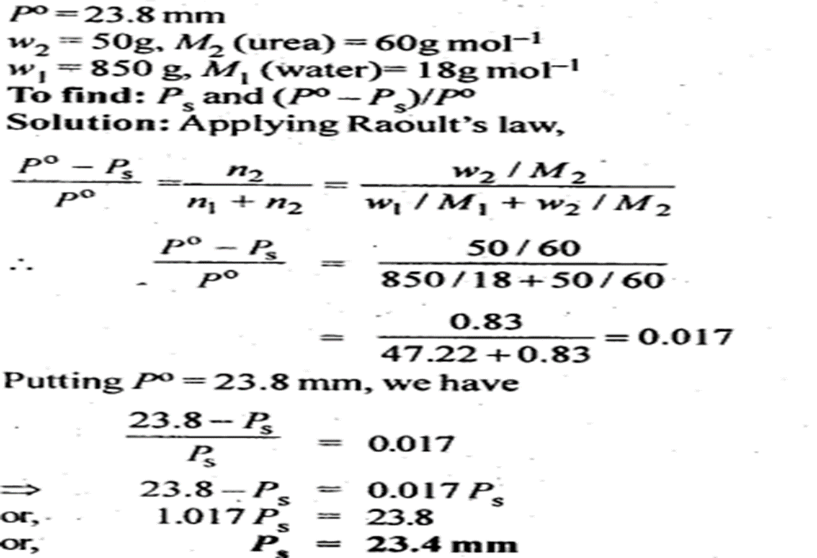
Section C

Ans 13.(i)8MnO₄²⁻ + S₂O₃²⁻ + H₂O → 8MnO₂ + 6 SO₄²⁻ + 2OH⁻
(ii)Cr₂O₇2- + 6Fe²⁺ +14 H⁺ → 2Cr³⁺ +6 Fe³⁺ + 7H₂O
(iii) Cr₂O₇²⁻ + H⁺ + I⁻ →2 Cr³⁺ (aq) + 3 I₂ + 7 H₂O
Ans 14 (i) The differential rate equation will be
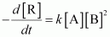
(ii) If the concentration of B is increased three times, then
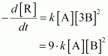
Therefore, the rate of reaction will increase 9 times.
(iii) When the concentrations of both A and B are doubled,
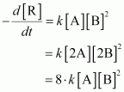
Q.15
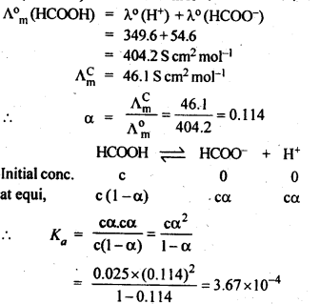
Q16. Calculation of Van’t Hoff factor (i)
K₂SO₄ dissociates in water as :
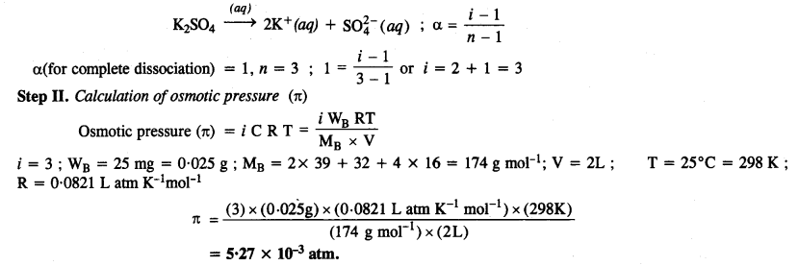

Section D
Ans 17(a) It shows ionisation isomerism and linkage isomerism.
(b) Chelate effect: When a bidentate or a polydentate ligand contains donor atoms positioned in such a way that when they coordinate with the central metal ion, a five or a six membered ring is formed. This effect is called Chelate effect. As a result, the stability of the complex increases. Example: the complex of Ni2+ with ‘+ion’ is more stable than NH3.
(c) Law spin tetrahedral complexes are rarely observed because orbital splitting energies for tetrahedral complexes are sufficiently large for forcing pairing.
(d) In both the cases, Fe is in oxidation state +3. Outer electronic configuration of Fe+3 is :
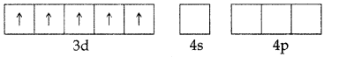
In the presence of CN–, the 3d electrons pair up leaving only one unpaired electron. The hybridisation involved is d2sp3 forming inner orbital complex which is weakly paramagnetic. In the presence of H2O (a weak ligand), 3d electrons do not pair up. The hybridisation involved is sp3d2 forming an outer orbital complex. As it contains five unpaired electrons so it is strongly paramagnetic. .
(e) In [Co(NH3)6]3+, the d-electrons of Co3+ ([Ar]3d6 45°) get paired leaving behind two empty d-orbital and undergo d2sp3 hybridization and hence inner orbital complex, while in [Ni(NH3)6]2+ the d-electrons of Ni2+ ([Ar]3d8 45°) do not pair up and use outer 4d subshell hence outer orbital complex.
(f) IUPAC name : Tetraaminedichloridochromium (III) ion.
It exhibits geometrical isomerism.
(g) Dichloridobis(ethylenediamine)Cobalt(III)ion
Ans 18
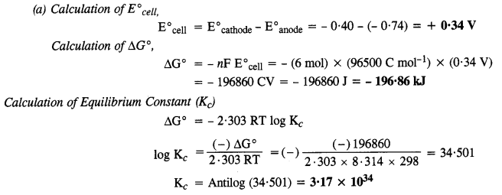
(b)
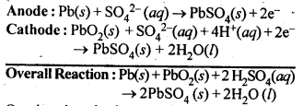
OR
- The set-up will be similar to as shown below,
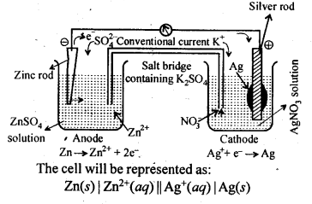
(i) Anode, i. e, zinc electrode will be negatively charged.
(ii) The current will flow from silver to copper in the external circuit.
(iii) At anode: Zn(s) ——–> Zn²⁺(aq) + 2e–
At cathode: 2Ag⁺(aq) + 2e– ——–> 2Ag(s)

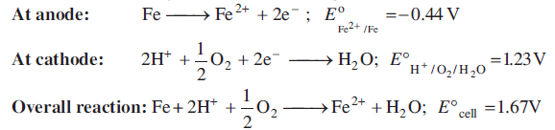

PRACTICE PAPER BOOK 1 SET 10
CLASS XII CHEMISTRY

S.No. | Name of Chapter | MCQ | A/R | SA1 | SA2 | Case Base | LA | Total
S.No. | Name of Chapter | 1 mark | 1 Mark | 2 Mark | 3 mark | 4 Mark | 5 mark
1 | Solutions | 2(2) | - | 2(1) | 3(1) | - | - | 7(4)
2 | Electrochemistry | 2(2) | - | 4(2) | 3(1) | - | - | 9(5)
3 | Chemical Kinetics | 2(2) | - | - | - | - | 5(1) | 7(3)
4 | d and f Block Elements | 2(2) | - | - | - |  | 5(1) | 7(3)
5 | Coordination Compounds | 1(1) | 2(2) | - | - | 4(1) |  | 7(4)
 | Total | 9(9) | 2(2) | 6(3) | 6(2) | 4(1) | 10(2) | 37(19)

Set 10
Practice Paper BOOK 1 (2023-24)
MM:37 CHEMISTRY THEORY (043) Time: 1 ½ hours
SECTION -A
The following questions are multiple choice questions with one correct answer. Each question carries 1 mark. There is no internal choice in this section.
- Which of the following aqueous solution should have highest boiling point?
(a)1.0MNaOH (b)1.0 MK₂SO₄ (c)1.0 M NH₄NO₃ (d)1.0 M KNO₃

- Which of the following non-ideal solutions shows negative deviation from Roult’s law?
(a)Chlorobenzene and Bromobenzene (b)Acetone and Ethanol
(c)Acetone and Chloroform (d)Ethanol and Water

- The electrode potential of Hydrogen electrode at pH = 10 is highest
(a)0.59 V (b)0.0 V (c)-0.59 V (d)-0.059V

- How much charge is required for reduction of 1 mol of MnO₄ – to Mn²⁺
(a)3F (b)2F (c)4F (d)5F

- The conversion of AB follows second order kinetics. Doubling the concentration of A will increase the rate of formation of B by a factor of
(a)4 (b)3 (c)1/4 (d)1/2

- 6.The increase in rate constant of a chemical reaction with increasing temperature is due to the fact that
(a)The activation energy of the reaction decreases with increasing temperature
(b)The concentration of the reactant molecules increases with increasing temperature
(c)The number of reactant molecule acquiring the activation energy increases with increasing temperature
(d)All of above

- Which of the following oxidation state is common for all lanthanoids
(a)+2 (b)+3 (c)+4 (d)+5

- Which of the following is not the characteristic property of interstitial compounds
(a)They are very hard (b)They retain metallic conductivity (c)They have high melting points in comparative pure metals
(d)They are chemically very reactive

- How many ions are produced from the complex [Co (NH₃)₅Cl] Cl₂ in solution
(a)4 (b)2 (c)3 (d)5

In these questions (No. 13 to 16) a statement of Assertion(A) followed by statement of Reason is given. Choose the correct answer out of the following choices

(a)Both A and R are true and R is correct explanation of A.
(b) Both A and R are true but R is not correct explanation of A.
(c)A is true but R is false.
(d)A is false but R is true.

- Assertion: The complex ion cis-[Co(en)₂Cl₂]⁺ is optically active.
Reason: It is an octahedral complex.

- Assertion: [Ni(CO)₄]is diamagnetic complex.
Reason: It involves sp³ hybridisation and there is no unpaired electron.

SECTON -B
This section contains five questions with internal choice in one question. The following questions are very short answer type and carry two marks each.

- Calculate the mass of urea (NH₂CONH₂) required in making 2.5 kg of 0.25 molal aqueous solution.
- The molar conductivity of sodium acetate, sodium chloride and hydrochloric acid are 83,127 and 426 mho ${cm}^{2}{mol}^{-1}$ at ${250}^{∘}C$ respectively. Calculate the molar conductivity of acetic acid solution.
- On the basis of E^{O} value oxygen gas should be liberated at anode but it is Cl₂ gas which is liberated in the electrolysis of aqueous NaCl. give reason.

Section -C
This section contains seven question with internal choice in one question. The following question are short answer type and carry 3 marks each.

- State Henry’s law and mention two important applications.
- Determine the values of equilibrium constant (K_{c}) and ΔG° for the following reaction:
Ni(s) + 2Ag⁺ (aq) → Ni²⁺ (aq) + 2Ag(s); E° = 1.05 V (1F = 96500 C mol⁻¹)
Section -D
The following questions are case based question each question has internal choice and carries four marks (1+1+2) each. Read the passage carefully and answer the questions that follow.

- Arrangement of ligands in order of their ability to cause splitting Δ is called spectrochemical series. Ligands which cause large splitting (large Δ) are called strong field ligands while those which cause small splitting (small Δ) are called weak field ligands. When strong field ligands approach metal atom ion, the value of Δ_{o} is large, so that electrons are forced to get paired up in lower energy t_{2g} orbitals. Hence, a low-spin complex is resulted from strong field ligand. When weak field ligands approach metal atom/ion, the value of Δ_{o} is small, so that electrons enter high energy e_{g} orbitals rather than pairing in low energy t_{2g} orbitals. Hence, a high-spin complex is resulted from weak field ligands. Strong field ligands have tendency to form inner orbital complexes by forcing the electrons to pair up. Whereas weak field ligands have tendency to form outer orbital complex because inner electrons generally do not pair up.
(i)On the basic of CFT write the electronic configuration for d4 ion if Δ_{o} < P.
(ii)Calculate number of unpaired electrons in [FeF₆]⁴⁻.
(iii) Why are low spin tetrahedral complexes not formed?
Or
(iii) Write the difference between crystal field stabilising energy and crystal field splitting energy

Section -E
The following question are long answer type and carry five marks each. All question have internal choice.
- Attampt any five of following
(a)Which transition metal of 3d -series has positive Eº (M²⁺/M) value.
(b) Out of Cr³⁺, Mn³⁺, which is stronger oxidising agent and why?
(c)Name a member of lanthanoid series which is well sure to exhibit +4 oxidation state.
(d)What happen potassium chromate is acidified2CrO₄²⁻ + 2H⁺ -----> (e)KMnO₄ ----heat---
(f)Cu²⁺, is more stable than cu⁺¹ in aqueous solution, why?
(g) Enthalpy of atomisation of transition element is very high. assign the reason?

- (a)The rate of the chemical reaction doubles for an increase of 10 K in absolute temperature from 298 K. Calculate E_{a}.
(b)What value of k is predicted for the rate constant by Arrhenius equation if temperature is infinite? is this value physically responsible?
(c) Why does equilibrium constant not change with presence of a catalyst?
Or
(a) Rate constant k of a reaction varies with temperature according to the equation log k = log A −Ea/2.303RT; where E_{a} is the energy of activation for the reaction. When a graph is plotted for log k vs 1/T a straight line with a slope −6670K is obtained. The activation energy for this reaction will be? (R=8.314 JK⁻¹ mol⁻¹)
(b)What is fraction of molecule having energy equal to or greater than activation energy? What is the quantity called?
(c) An exothermic reaction A converts into B has an activation energy 17 kJmol⁻¹ of A. The heat of reaction is 40 kJ. Calculate the activation energy for the reverse reaction from B to A.

PRACTICE PAPER BOO 1 SET 10
MARKING SCHEME
Q | 1 | 2 | 3 | 4 | 5 | 6 | 7 | 8 | 9 | 10 | 11
ANS | b | c | c | d | a | c | b | d | c | b | a

Q.NO | ANSWER | MARKS
12 | 0.25 Molal aqueous solution to urea means that  moles of urea = 0.25 mole  mass of solvent (NH₂CONH₂) = 60 g mol⁻¹  .’. 0.25 mole of urea = 0.25 x 60=15g  Mass of solution = 1000+15 = 1015g = 1.015 kg  1.015 kg of urea solution contains 15g of urea  .’. 2.5 kg of solution contains urea =15/1.015 x 2.5 = 37 g | 1+1
13 | Given : $Λ_{m}^{∘}\left({CH}_{3}COONa\right)=83 mho {cm}^{2}{mol}^{-1}$  $$Λ_{m}^{∘}\left(NaCl\right)=127 mho {cm}^{2}{mol}^{-1} \\ Λ_{m}^{∘}\left(HCl\right)=426 mho {cm}^{2}{mol}^{-1}$$$Λ_{m}^{∘}\left({CH}_{3}COOH\right)=$ ?  Using Kohlrausch law of independent migration of ions  $Λ_{m}^{∘}\left({CH}_{3}COOH\right)=Λ_{m}^{∘}\left({CH}_{3}COONa\right)+Λ_{m}^{∘}(HCl)-Λ_{m}^{∘}(NaCl)$ or${ Λ}_{m}^{∘}\left({CH}_{3}COOH\right)=83+426-127$  $$=382 mho {cm}^{2}{mol}^{-1}$$ | 1+1
14. | From standard oxidation potential oxygen gas should be liberated at anode but this reaction is very slow, in order to increase we have to increase the voltage of external battery. Because of which chloride ion get oxidise easily and liberated at anode. | 1+1
15 | Answer: Henry’s Law: Effect of pressure on solubility of gases in liquids at a particular temperature is given by Henry’s law. “The mass of a gas dissolved in a given volume of the liquid at a constant temperature is directly proportional to the pressure of the gas present in equilibrium with the liquid.”  Mathematically m ∝ p  . m = kp  P= K_{H} x  where m = mass of the gas dissolved in a unit volume of the solvent  p = Pressure of the gas in equilibrium with the solvent  k = Constant called Henry’s Law constant.  Two applications of Henry’s law:  1. To increase the solubility of CO₂ in soft drinks and soda-water, the bottle is sealed under high pressure.  2. Deep sea divers use oxygen diluted with less soluble helium as breathing gas to minimise the painful effects accompanying the decompression.  3. In lungs where oxygen is present in air with high partial pressure, haemoglobin combines with oxygen to form oxyhaemoglobin. In tissues where partial pressure of oxygen is low it releases oxygen for utilization in cellular activities. | 1+1+1
16 | According to the formula  ΔG° = -nFE° = – 2 × 96500 ×1.05  or ΔG° = -202650 J mol⁻¹ = -202.65 KJ mol⁻¹  Now ΔG° ⇒ -202650 J Mol⁻¹  R = 8.314 J/Mol/K, T = 298 K  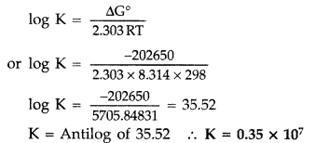 | 1 +1+1
17 | (i) t_{2g}³ e_{g}¹  (ii) 4  (iii)Crystal field splitting energy for tetrahedral complex have almost half of octahedral. Δ_{t}=4/9 Δ_{o}  Or  (iii) Energy difference between splited lower energy and upper energy level is termed as crystal field splitting energy whereas energy liberated redistribution of electron in spilited orbitals. | 1+1+2
18 | (a)copper (b) Mn^{3+,} Due to 3d⁵ half field configuration (c)Ce (d)Potassium dichromate is formed (e) KMnO₄ ----heat--- K₂MnO₄ +MnO₂ +O₂ (f)Second ionisation enthalpy of copper compensate with hydration enthalpy of Cu²⁺  (g) Transition metal have large number of unpaired electron forms stronger metal metal bonding. | 1+1+1+1+1
19 | 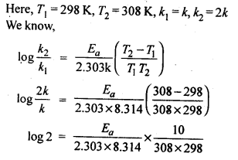  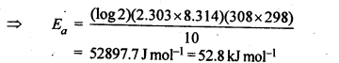  (b) if temperature is infinite k = A so that Ea = 0, this will not feasible  (c) Catalyst increase the rate of forward and backward reaction to the same extent. therefore, equilibrium attain quickly but the position equilibrium does not change. | 3+1+1
19(or) | Slope of the line = −Ea/2.303R ​​=−6670K  Ea = Slope x 2.303 x 8.314  Ea​=2.303×8.314(JK⁻¹mol⁻¹) × 6670K  = 127711.4 Jmol⁻¹=127.71 kJ mol⁻¹  (b) fraction of molecule having energy equal to or greater than activation energy is equal to e-Ea /RT at temp T. It is called Boltzmann factor.  ( c) A ---- B Ea=17 kJ  Since the reaction is exothermic, the energy of product is less than that of reactant, hence B- A  Ea (reverse)=Ea(forward) + ΔE  Ea (reverse)=17 +40=57 kJ | 3+1+1

 | Practice paper BOOk 1 ( 2023-24) BLUE-PRINT SET 11
 | Class XII CHEMISTRY
 |  |  | Class: XII
S.No | Chapter | MCQ | A/R | VSA I | SA I | Case Based | LA | Total wt
S.No | Chapter | 1 Marks | 1  Marks | 2 Marks | 3 Marks | 4  Marks | 5  Marks
1 | Solutions | 2(2) |  | 2(1) | 3(1) |  |  | 7(4)
2 | Electrochemistry | 1(1) |  |  | 3(1) |  | 5(1) | 9(3)
3 | Chemical Kinetics | 1(1) |  | 2(1) |  | 4(1) |  | 7(3)
4 | d -and f -Block Elements | 2(2) |  |  |  |  | 5(1) | 7(3)
5 | Coordination Compounds | 1(1) | 1(1) | 2(1) | 3(1) |  |  | 7(4)
 | Total | 7 (7) | 1(1) | 6(3) | 9(3) | 4(1) | 10(2) | 37(17)

Set 11
Practice Paper BOOK 1 (2023-24)
MM:37 CHEMISTRY THEORY (043) Time: 1 ½ hours
SECTION A
The following questions are multiple -choice questions with one correct answer. Each question carries 1 mark. There is no internal choice in this section.
- When a non-volatile solid is added to pure water it will:
(a) boil above 100ºC and freeze above 0ºC (b) boil below 100ºC and freeze above 0ºC
(c) boil above 100ºC and freeze below 0ºC (d) boil below 100ºC and freeze below 0ºC
- In reverse osmosis:
(a) a pressure greater than osmotic pressure is applied on pure water side
(b) a pressure lesser than osmotic pressure is applied on pure water side
(c)a pressure greater than osmotic pressure is applied on salt water side
(d)a pressure lesser than osmotic pressure is applied on salt water side
- Which cell will measure standard electrode potential of copper electrode?
- Pt(s)| H₂ (g, 0.1 bar)| H⁺ (aq., 1 M) | | Cu²⁺ (aq., 1M)| Cu(s)
- Pt(s)| H₂ (g, 1 bar) | H⁺ (aq., 1 M) | | Cu²⁺ (aq., 2M)| Cu(s)
- Pt(s)| H₂ (g, 1 bar) | H⁺ (aq., 1 M) | | Cu²⁺ (aq., 1M)| Cu(s)
- Pt(s)| H₂ (g, 1 bar) | H⁺ (aq., 0.1 M)| | Cu²⁺ (aq., 1M)| Cu(s)
- The unit of rate and rate constant are same for a reaction
(a) zero order (b)first order (c) second order (d) third order
- Interstitial compounds are formed when small atoms are trapped inside the crystal lattice of metals. Which of the following is not the characteristic property of interstitial compounds?
(a) They have high melting points in comparison to pure metals.
(b) They are very hard.
(c) They retain metallic conductivity.
(d) They are chemically very reactive.
- Transition elements form alloys easily because they have
(a) Same atomic number (c) Nearly same atomic size
(b) Same electronic configuration (d) None of the above
- Which of the following complex show linkage isomerism?
(a) [Co(NH₃)₅ (NO₃)]²⁺ (c) [Cr(NH₃)₅ SCN]²⁺
(b) [Co(H₂O)₅CO]³⁺ (d) [Fe(en)₂Cl₂]⁺
    - ${CH}_{3}{CH}_{2}{COCH}_{3}$ (d) ${CH}_{3}COOH+HCOOH$
In the Following questions a statement of Assertion(A) is followed by a statement of Reason(R). Select the most appropriate answer from the options given below:
a. Both A and R are true and R is the correct explanation of A
b. Both A and R are true but R is not the correct explanation of A.
c. A is true but R is false.
d. A is false but R is true.
- Assertion (A) : All the ligands must contain one donor atom.
Reason(R) : All inner orbital complexes are diamagnetic..

SECTION B
This section contains 5 questions with internal choice in one question. The following questions are very short answer type and carry 2 marks each.
- (a)How the osmotic pressure of 5 % aqueous solution of glucose (𝜋₁) is related to that of 5 % aqueous solution of urea (𝜋₂)?
(b) Why do salt water fish die when they are suddenly transferred to a fresh water aquarium?
- A reaction is first order in A and second order in B. Write the rate equation and how the rate is affected when concentration of B is tripled.
- (i)On the basis of crystal field theory, write the electronic configuration for d⁴ ion if $∆$o $<$ P.
(ii)What is the oxidation state and hybridization of Ni in [Ni(CO)₄] ?
OR
Explain the following:
(i)Anhydrous ${CuSO}_{4}$ is white while hydrated ${CuSO}_{4}$ is blue in colour.
(ii)$[Ti(H_{2}O)_{6}]{Cl}_{3}$ is violet in colour but becomes colourless on heating.

SECTION C
This section contains 7 questions with internal choice in one question. The following questions are short answer type and carry 3 marks each.

- Calculate the mass of NaCl (molar mass = 58.5 ${g mol}^{-}$¹) to be dissolved in 37.2 g of water to lower the freezing point by 2°C, assuming that NaCl undergoes complete dissociation. (K_{f} for water = 1.86 $K kg{mol}^{-1}$)
OR
When 2.56 g of sulphur was dissolved in 100 g of CS₂, the freezing point lowered by 0.383 K . Find out the formula of sulphur (S_{X}). (K_{f} for CS₂=3.83 Kkg mol⁻¹, atomic mass of sulphur =32 g mol⁻¹)
- Calculate the cell emf and $ΔG^{∘}$ for the cell reaction at ${25}^{∘}C$ for the cell :
$Zn(s)\left|{Zn}^{2+}\left(0.0004M\right)∥{Cd}^{2+}\left(0.2M\right)\right|Cd(s)$
Given: $E_{{Zn}^{2+}/Zn}^{o}=-0.76 V, E_{{Cd}^{2+}/Cd}^{o}=-0.40 V$ $F=96500C{mol}^{-1}$; log2=0.3010
- CoSO₄Cl.5NH₃ exists in two isomeric forms ‘A’ and ‘B’. Isomer ‘A’ reacts with AgNO₃ to give white precipitate, but does not react with BaCl₂. Isomer ‘B’ gives white precipitate with BaCl₂ but does not react with AgNO₃. Answer the following questions.
(i) Write the structural formulas and IUPAC names of A and B.
(ii) Name the type of isomerism involved.

SECTION D
The following questions are case -based questions. Each question has an internal choice and carries 4 (1+1+2) marks each. Read the passage carefully and answer the questions that follow.
- The rate of a reaction, which may also be called its velocity or speed, can be defined with relation to the concentration of any of the reacting substances, or to that of any product of the reaction. If the species chosen is a reactant which has a concentration c at time t the rate is - dc/dt, while the rate with reference to a product having a concentration x at time t is dx/dt. Any concentration units may be used for expressing the rate; thus, if moles per litre are employed for concentration and seconds for the time, the units for the rate are moles liter-1 sec-1. For gas reactions pressure units are sometimes used in place of concentrations, so that legitimate units for the rate would be (mm. Hg) sec⁻¹ and atm. sec⁻¹. The order of a reaction concerns the dependence of the rate upon the concentrations of reacting substances; thus, if the rate is found experimentally to be proportional to the α th power of the concentration of one of the reactants A, to the β th power of the concentration of a second reactant B, and so forth, via.,
Rate = k C_{A} ^{α} C_{B} ^{β} ---------(1)
The over-all order of the reaction is simply
x = α + β + ----- ------- (2)
Such a reaction is said to be of the α th order with respect to the substance A, the β th order with respect to B and so on...
(Laidler, K. J., & Glasstone, S. (1948). Rate, order and molecularity in chemical kinetics. Journal of Chemical Education, 25(7), 383.)
Answer the following questions:
  - A first order reaction has a rate constant k = 5.5 × 10^{–14} $s^{-1}$. Determine the half-life of reaction.
  - If the half-life period of a first order reaction in A is 2 minutes, then find the time required by [R] to reach 25% of its initial concentration?
  - How the half-life period for a zero-order reaction related to the initial concentration of reactant? Draw graph $t_{½}$ v/s initial concentration [R]₀ for the zero-order reaction.
OR
- Following graph represent which order of reaction. What is the lope of the line in this graph?
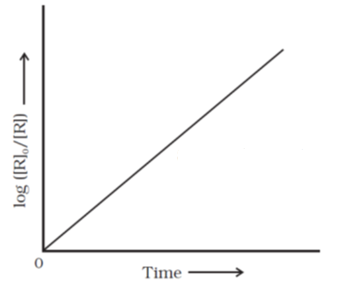

SECTION E
The following questions are long answer-type and carry 5 marks each. All questions have an internal choice.

- (a) What is the role of ZnCl₂ in a dry cell
(b) Unlike dry cell, the mercury cell has a constant cell potential throughout its useful life. why? (c)Depict the galvanic cell in which the reaction Zn(s) + 2Ag⁺ (aq) → Zn²⁺ (aq) + 2Ag(s) takes place. Further show: (i) Which of the electrode is negatively charged?
(ii) The carriers of the current in the cell.
OR
(a)Why does the conductivity of a solution decrease with dilution?
(b)Given the standard electrode potentials,
$K^{+}/K$ = –2.93V, ${Ag}^{+}/Ag$ = 0.80V, ${Hg}^{2+}/Hg$ = 0.79V, ${Mg}^{2+}/Mg$= –2.37 V, ${Cr}^{3+}/Cr$ = – 0.74V
Arrange these metals in their increasing order of reducing power.
(c) What material is used as anode and cathode in lead storage battery. Write the half and overall
equations of reactions taking place during recharging of lead storage battery.

- (a) When pyrolusite ore MnO₂ is fused of with KOH in presence of air, a green coloured compound (A) is obtained which undergoes disproportionation reaction in acidic medium to give purple coloured compound (B).
- Write the formulae of (A) & (B).
- What happens when compound (B) is heated.
(b) What is Lanthanoid contraction? Give its cause. What are its Consequences?

OR
(a)When chromite ore FeCr₂O₄ is fused with NaOH in presence of air, a yellow coloured
compound (A) obtained which on acidification with dilute sulphuric acid gives a compound
(B).Compound (B) on reaction with KCl forms an orange coloured crystalline compound
(C).
        - Write the formulae of (A), (B) & (C).
        - Write one use of compound (C).
(b)Compare the chemistry of actinoids with that of the lanthanoids with special reference to:
(i) electronic configuration (ii) oxidation state (iii) chemical reactivity.

Practice paper BOOK 1 Class XII Chemistry (2023-24) Set 11
Marking Scheme with Answer Key
MM:70 CHEMISTRY THEORY (043) Time: 3 hours

QNo | 1 | 2 | 3 | 4 | 5 | 6 | 7 | 8
Answer | c | c | c | a | d | c | c | c

Q. No | Probable Answer | Weightage
9 | - 𝜋₁ < 𝜋₂  - Water from aquarium enters in cell causing them to expand and get ruptured. | 1+1
10 | Rate(R)=k[A][B]²  rate increases 9 times. | 1 +1
11 | (i)t_{2g}³eg¹ (ii) 0 , ${sp}^{3}$  OR  (i) Anhydrous ${CuSO}_{4}$ has no ligand. So, crystal field splitting does not occur so, it does not show any colour but in hydrated form it is linked with $H_{2}O$ ligand so, it shows colour due to d-d transition.  (ii) $[Ti(H_{2}O)_{6}]{Cl}_{3}$ is a complex compound. In presence of 6$H_{2}O$ molecules the d-orbitals of ${Ti}^{3+}$undergo splitting. The compound is coloured (violet) due to d-d transition. On heating water molecules escape, d-orbitals become degenerate. There is no d-d transition. Hence compound becomes colourless. | 1+1
12 | 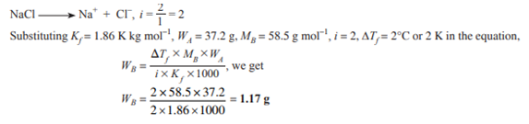  OR  $$∆T_{f}=\frac{K_{f}× W_{b} ×1000}{M_{b} ×W_{a}}$$  $$0.383=\frac{3.83 ×2.56 ×1000}{M_{b} ×100}$$  $M_{b}=256$  S × x =256, 32 × x =256, x = 8 so formula of sulphur is $S_{8}$ | 1  1  1  1  1  1
13 | $$\begin{matrix}E_{\text{cell }}^{∘}=E_{\text{cathode }}^{∘}-E_{\text{anode }}^{∘} & =-0.40-\left(-0.76\right)=3.36V \\ & \end{matrix}$$  The net cell reaction is, ${Zn}_{(s)}+{Cd}_{(\text{aq })}^{2+}→{Zn}_{(\text{aq })}^{2+}+{Cd}_{(s)}$, n=2  $$\begin{matrix} & E_{\text{cell }}=E_{\text{cell }}^{∘}-\frac{0.0591}{2}\log{\frac{\left[{Zn}^{2+}\right]}{\left[{Cd}^{2+}\right]}} =3.44 V, \\ & ΔG^{∘} = -nFE_{\text{cell }}^{∘}= -2 x 96500 x 3.36=-648480 J/mol \\ & \\ & \\ & \end{matrix}$$ | ½  ½  1  1
14 | - A - [Co(NH₃)₅SO₄]Cl , ), Pentaamminesulphatocobalt (III) chloride  B - [Co(NH₃)₅Cl]SO₄ , Pentaamminechlorocobalt (III) sulphate  - Ionisation isomerism | 2  1
15 | - 0.693/5.5x10⁻¹⁴ s =$0.126 ×{10}^{14} s$  - 4 minutes  - Half life period is directly proportional to the initial concentration  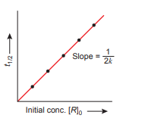  OR  (c)First order reaction  Slope=k/2.303 | 1  1  1+1=2
16 | (a) ZnCl₂ combines with the NH₃ produced to form the complex salt [Zn(NH₃)₂ Cl₂] otherwise the pressure developed due to NH₃ would crack the seal of the cell  (b) Ions are not involved in the overall cell reaction of mercury cells  (c)Cell can be represented as Zn | Zn²⁺ (aq) ||Ag⁺ (aq) |Ag.  - zinc electrode is negatively charged (anode)  - Ions are the current carriers within the cell  OR  - number of ions per unit volume that carry the current in a solution decrease on dilution.  - Ag , Hg, Cr, Mg, K  - lead anode and a grid of lead packed with lead dioxide (PbO2 ) as cathode.  At cathode: PbSO₄ (s) +2e– → Pb(s) + SO₄ ^{2–}(aq)  At anode: PbSO₄ gets oxidised to PbO₂  PbSO₄ (s) + 2H₂O → PbO₂ (s) + 4H⁺(aq) + SO₄^{2–}(aq) + 2e–  Overall Reaction: PbSO₄ (s) + 2H₂O(l) → Pb(s) + PbO₂ (s) + 2H₂SO₄ (aq) | 1  1  1  1  1  1  1  1  2
17 | (a) (i)A= K₂MnO₄ B=KMnO₄  (ii)2KMnO₄K₂MnO₄ + MnO₂ + O₂  (b)Lanthanoid contraction: The regular decrease in the atomic and ionic radii of lanthanoids with increasing atomic number is known as Lanthanoid contraction.  Cause: - due to poor shielding effect of 4f electrons.  Consequences :- separations of lanthanoids are difficult, Similarity in size of elements belonging to same group of second and third transition series due to lanthanoid contraction the size of Zr (160 pm) is same as that of Hf(159 pm).]  OR  (a)(i) A = Na₂CrO₄ B= Na₂Cr₂O₇ C= K₂Cr₂O₇  (ii) Potassium dichromate is used as a primary standard in volumetric analysis.  (b) | ½ + ½  1  1  1  1  ½ +½ +½  ½  3
  Property | Lanthanoids | Actinoids
  (i)Electronic configuration | 4f orbital is filled | 5f orbital is filled
  (ii) Oxidation state | +3, +2, +4 | +3, +4, +5, +, +7
  (iii)Chemical reactivity | Less reactive | More reactive

PRACTICE PAPER BOOK 1 SET 12 2023-24
BLUE-PRINT SUBJECT- CHEMISTRY
Class: XII
S.No | Chapter | MCQ | A/R | VSA I | SA I | Case Based | LA | Total
S.No | Chapter | 1 Marks | 1  Marks | 2 Marks | 3 Marks | 4  Marks | 5  Marks
1 | Solutions |  |  | 2(1) |  |  | 5(1) | 7(2)
2 | Electrochemistry | 2(2) |  |  | 3(1) | 4(1) |  | 9(4)
3 | Chemical Kinetics | 1(1) | 1(1) | 2(1) | 3(1) |  |  | 7(4)
4 | d -and f -Block Elements | 2(2) |  |  |  |  | 5(1) | 7(3)
5 | Coordination Compounds |  |  |  | 3(1) | 4(1) |  | 7(2)
 | Total | 5(5) | 1(1) | 4(2) | 9(3) | 8(2) | 10(2) | 37(15)

Set 12
Practice Paper BOOK 1 (2023-24)
MM:37 CHEMISTRY THEORY (043) Time: 1 ½ hours
SECTION A
The following questions are multiple-choice questions with one correct answer. Each question carries 1 mark. There is no internal choice in this section.
Q.N. | QUESTIONS | MARKS
1 | In which of the following pairs both the ions are coloured in aqueoussolution?  - Sc³⁺ , Ti³⁺ (b) Sc^{3+,} Co²⁺ (c) Ni²⁺ , Cu⁺ (d) Ni^{2+,} Ti³⁺ | 1
2 | The difference between the electrode potentials of two electrodes when no current is drawn through the cell is called  (a) Cell potential (b) Cell emf (c) Potential difference (d) Cell voltage | 1
3 | KMnO₄ is not acidified by HCl instead of H₂SO₄ because  (a) H₂SO₄ is stronger acid than HCl (b) HCl is oxidised to Cl₂ by KMnO₄  (c) H₂SO₄ is dibasic (d) rate is faster in presence of H₂SO₄ | 1
4 | The increase in rate constant of a chemical reaction with increasing temperature is due to the fact that  (a)The activation energy of the reaction decreases with increasing temperature  (b)The concentration of the reactant molecules increases with increasing temperature  (c)The number of reactant molecule acquiring the activation energy increases with increasing temperature  (d)All of above | 1
5 | In a lead storage battery  (a)PbO₂ is reduced to PbSO₄ at the cathode  (b) Pb is oxidised to PbSO₄ at the anode  (c ) Both electrodes are immersed in the same aqueous solution of H₂SO₄  (d) All the above are true | 1

In the Following questions a statement of Assertion(A) is followed by a statement of Reason(R). Select the most appropriate answer from the options given below:
(a) Both A and R are true and R is the correct explanation of A
(b) Both A and R are true but R is not the correct explanation of A.
(c) A is true but R is false.
(d) A is false but R is true.
6 | Assertion: Conductivity decreases for weak electrolyte and increases for strong  electrolyte with decrease in concentration.  Reason: On dilution, the number of ions per unit volume that carry the current decreases. | 1

SECTION B
This section contains 5 questions with internal choice in onequestion. The following questions are very short answer type and carry 2 marks each.
7 | Suman took two glasses of water from a water filter. She cools one glass in a fridge and warms the other glass on a stove. Which glass of water will hold more dissolved oxygen? Explain using Henry's law. | 2
8 | If hydrolysis of cane sugar is completed in acidic medium then its rate of reaction depends only on one molecule of cane sugar.  (i)What will be the name of the reaction  (ii) What will be unit of rate constant for this reaction? | 2

SECTION C
This section contains 7 questions with internal choices in one question. The following questions are short answer types and carry 3 marks each.
9 | A strip of nickel metal is placed in a 1 molar solution of $Ni{\left({NO}_{3}\right)}_{2}$ and a strip of silver metal is placed in a 1 molar solution of ${ AgNO}_{3}$. An electrochemical cell is created when the two solutions are connected by a salt bridge and the two strips are connected by wires to a voltmeter.  (i) Write the balanced equation for the overall reaction occurring in the cell .  (ii) Calculate the cell potential, $E$, at ${25}^{∘}C$ for the cell if the initial concentration of $Ni{\left({NO}_{3}\right)}_{2}$ is $0.100$ molar and the initial concentration of ${AgNO}_{3}$ is $1.00$ molar.  $$\left[E_{{Ni}^{2+}/Ni}^{0}=-0.25V;E_{{Ag}^{+}/Ag}^{0}=0.80V,log⁡{10}^{-1}=-1\right]$$ | 3
10 | What do you mean by rate constant? The rate constant of a first order reaction increases from 4 x 10⁻² to 24 x 10⁻² when the temperature changes from 300 K to 350 K. Calculate the energy of activation (Ea). (log 2 = 0.3010, log 3 = 0.4771, log 4 = 0.6021, log 6 = 0.7782) | 3
11 | (a)Why are low spin tetrahedral complexes not formed  (b)[Fe(H₂O)₆]³⁺is strongly paramagnetic where as [Fe(CN)₆]³⁻is weakly paramagnetic. Explain. (At. no. Fe = 26) | 3

SECTION D
The following questions are case-based questions. Each question has an internal choice and carries 4 (1+1+2) marks each. Read the passage carefully and answer the questions that follow.

12 | Read the passage given below and answer the following questions:  A process in which on passing electricity electrolyte split into ions and ions are deposited at opposite electrode is called electrolysis.  Faraday’s First law of electrolysis: The amount of substance deposited or liberated during electrolysis is directly proportional to the quantity of electricity passed through the solution.  Faraday's Second law of electrolysis When same amount of current is passed through different electrolytes which are connected in series, the amount of substance deposited/ liberated from different electrolytes is directly proportional to their equivalent weight.  (a)Define electrochemical equivalent (Z).  (b) How much electricity in terms of Faraday is required to produce20⋅0 g of Ca from molten CaCl₂?  (c)A solution of Ni (NO₃)₂ is electrolysed between platinum electrodes using a current of 5 amperes for 20 minutes. What mass of Ni is deposited at the cathode? ( Atomic mass of Ni is 58.5 u)  OR  (c) A solution of CuSO₄ is electrolysed for 10 minutes with a current of 1⋅5 amperes. What is the mass of substance deposited at the cathode? (Atomic mass of Cu is 63 u) | 4
13 | Read the passage given below and answer the following questions:  Werner, a Swiss chemist prepared large no. of coordination compounds and studied their physical and chemical properties. He proposed that, in coordination compounds, metal possess two types of valences- primary and secondary valences. Primary valency is ionizable and secondary valency is non-ionizable. In a series of complexes of Co(III) chloride with ammonia, it was found that some of the chloride ions could be precipitated as AgCl on adding excess amount of AgNO₃ solution. The no. of ions furnished by a complex in a solution can be determined by precipitation reactions. The measurement of molar conductance of solution of complexes helps to estimate the no. of ions furnished by the complexes in solution.  (a)Write difference between primary and secondary valences.  (b) How many moles of AgCl are formed by the complex [Co(NH₃)₄Cl₂]Cl with excess amount of AgNO₃ solution.  (c) Calculate number of primary and secondary valences shown in [Co(NH₃)₅Cl]Cl_{2.}  OR  (c) Calculate number of primary and secondary valences shown in [Ni(H₂O)₆]Cl_{2.} | 4

SECTION E
The following questions are long answer type and carry 5 marks each. Two questions have an internal choice.
14 | (i)Calculate the freezing point of a solution containing 0.5 g KCl (Molar mass = 74.5 g/mol) dissolved in 100 g water, assuming KCl to be 92% ionized. K_{f}of water = 1.86 K kg / mol.  (ii)Which of the following solutions has higher freezing point?  0.05 M Al₂(SO₄)₃, 0.1 M K₃[Fe(CN)₆ ] Justify.  OR  (i) While performing practicals it is directed that the bottle of liquid ammonia is to be cooled before opening seal but Suman forgot to cool it before opening. What consequence she faced ?  (ii)Sia’s father is suffering from high blood pressure but he is advised to consume less quantity of common salt. Why?  (iii) Out of 1M sucrose and 1M urea solution which has more osmotic pressure?  (iv) A compound CuSO₄.5H₂O undergoes complete dissociation in water. What will be its value of Van’t Hoff factor?  (v) If molality of dilute solution is doubled,what will be the value of molal elevation constant(K_{b})? | 5
15 | Attempt any five of the following-  (a) Mn₂O₇ is acidic whereas MnO is basic.  (b) Among divalent ions of 3d transition series,Mn²⁺ exhibits maximum paramagnetism  (c)Actinoids show wide range of oxidation states.  (d)${Cu}^{2+}$ is stable in aqueous solution inspite of having ${3d}^{9}$ configuration. Why?  (e) The E° values of Mn and Zn is more negative. Give reason.  (f) The transition metals are generally paramagnetic in nature why?  (g) Scandium is a transition element but Zinc is not. Why? | 5

PRACTICE PAPER BOOK 1 SET 12
Class: XII SUBJECT: CHEMISTRY
Q.N. | 1 | 2 | 3 | 4 | 5 | 6
ANS- | d | b | b | c | d | d

Q.No. | Value Point/ Expected Answer | Marks
7 | Glass kept in a fridge will contain more oxygen. Because according to Henry’s law the partial pressure of the gas in vapour phase (p) is proportional to the mole fraction of the gas (x) in the solution. p = KH x  Henry constant is directly proportional to temperature. If temperature increases solubilty of gas will be decreases. | 1  1
8 | ( i) Pseudo first order reaction (ii) unit of k will be s⁻¹ or time⁻¹ | 1+1

9 | (i)Cell reaction: Ni + 2Ag⁺ → Ni²⁺ + 2Ag,  (ii) $E_{cell }^{o}=E_{R }^{o}-E_{L }^{o}=80-\left(-0.25\right)=1.05 V$  $E_{cell }=E_{cell }^{o}-\frac{0.059}{n}loglog\frac{\left[{Ni}^{2+}\right]}{{\left[{Ag}^{+}\right]}^{2}}$=1.0795V | 1  2
10 | Rate Constant: It is equal to the rate of reaction when molarity is 1M.  $log\frac{k_{2}}{k_{1}}$ = $\frac{E_{a}}{2.303R}$($\frac{1}{T_{1}}-\frac{1}{T_{2}}$) , = log $\frac{24 x{ 10}^{-2}}{{4 x 10}^{-2}}$ = $\frac{E_{a}}{2.303x8.314}$($\frac{1}{300}-\frac{1}{350}$)  E_{a}=$\frac{19.147x300x350}{50}\log{6}$, E_{a} = 19.147x2100x0.7782, Ea=31290Jmol⁻¹ ⁼ 31.29 k Jmol⁻¹ | 1  1  1
11 | (a) Low spin tetrahedral complexes are rarely observed because orbital splitting energies for tetrahedral complexes are not sufficiently large for forcing pairing.  (b)In both the cases, Fe is in oxidation state +3. Outer electronic configuration of Fe³⁺is:  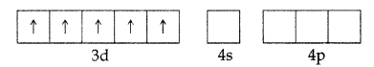  In the presence of CN–, the 3d electrons pair up leaving only one unpaired electron. The hybridisation involved is d²sp³ forming inner orbital complex which is weakly paramagnetic. In the presence of H₂O (a weak ligand), 3d electrons do not pair up. The hybridisation involved is sp³d² forming an outer orbital complex. As it contains five unpaired electrons so itis strongly paramagnetic. . | 1  2

12 | (a) Electrochemical equivalent is defined as the amount of substance deposited or liberated by the passage of 1 ampere of current for one second i.e. one coulomb charge.  (b) ${Ca}^{2+}+ {2e}^{-} →Ca$ To produce 40 g Ca, electricity needed = 2F  ∴ To produce 20 g Ca, electricity needed = 40/ 2 × 20 = 1F  (c) Quantity of electricity passed (Q) = Current in amperes × time in second = 5 × 20 × 60 = 6000 C  $${Ni}^{+2}+ {2e}^{-} →Ni$$  i.e. 2 × 96487 C of electricity deposit Ni = 58⋅5 g  ∴ 6000 C of electricity deposit Ni =(58.5/2 × 96487) × 6000 = 1⋅82 g  OR  (c) Quantity of electricity (Q) = Current × time = 1⋅5 × 10 × 60 = 900 C  According to the reaction: ${Cu}^{+2}+ {2e}^{-} →Cu$  We required 2 F or 2 × 96487 C of electricity to deposit 1 mol or 63 g of Cu  ∴ 900 C electricity will deposit = (63/2 × 96500) × 900 = 0⋅2938 g of Cu at the cathode. | 1  1  2
13 | (a). Primary valency is ionizable but secondary valency is not ionisable.  Primary valencies are satisfied only by anions no but secondary valencies are satisfied by both anions and neutral molecules  (b) One mole  (c) 3 and 6 OR 2 and 6 | 1  1  2
14 | (i)KCl → K⁺ + Cl⁻ n =2 i= 1-α + nα i=1+α(n-1) = 1 + α  ∆T_{f}= i.k_{f}m= (1+ 0.92) x1.86x0.5x1000/74.5x100 =0.24  ∆T_{f =}T_{f}^{o -}T_{f} T_{f}= - 0.24ºC  (ii)0.05 M Al₂(SO₄)₃ has higher freezing point. 0.05 M Al₂(SO₄)₃: i = 5,  ΔT_{f}α No of particles; ΔT_{f} = i x concentration = 5 x 0.05 = 0.25 moles of ions  0.1 M K₃ [Fe (CN)_{6]}i = 4,ΔT_{f} = 4 x 0.1 = 0.4 moles of ions  OR  (i)It is cooled to lower down the pressure of ammonia else the gas will bump out of the bottle.  (ii)More salt use will increase ions in the body fluid which increases blood pressure  (iii)Both have same osmotic pressure.  (iv) i=2  (v) K_{b} doesn’t depend upon ‘m’ so remain unchanged. | 3  2  1x5=5
15 | (a) Mn has + 7 oxidation state in Mn₂O₇ and +2 in MnO. In higher oxidation state of the metal, valence electrons involved in bonding and are not available. Instead effective nuclear charge is high and hence it accept electrons and behave as aLewisacid.  (b)Because Mn²⁺ contain 5 unpaired electrons in their 3d sub shells.  (c) This is due to comparable energies of 5f. 6d and 7s-orbitals.  (d)The high energy to transform Cu(s) to ${Cu}^{2+}$ (aq) is balanced by its hydration enthalpy.  (e) The stability of the half-filled d sub-shell in ${Mn}^{2+}$ and the completely filled $d^{10}$configuration in ${Zn}^{2+}$are related to their more negative E° V values.  (f) due to incomplete d orbitals and presence of unpaired electron.  (g)Because of fully filled d orbitals in zinc and in Zn²⁺ | 1x5=5

PRACTICE PAPER BOO 1 SET 13 CLASS –XII SESSION - (2023 -24)
SUBJECT – CHEMISTRY
S NO | NAME OF CHAPTER | MCQ  (1Mark) | Assertion & reason | SA I (2 Mark) | SA TYPE-II ( 3 Mark) | Case Based  (4 Marks) | LONG ANSWER  (5MARKS) | TOTAL  marks
1 | Solutions |  |  | 2(1) |  |  | 5(1) | 7(2)
2 | Electrochemistry | 1(1) | 1(1) |  | 3(1) | 4(1) |  | 9(4)
3 | Chemical Kinetics | 2(2) |  | 2(1) | 3(1) |  |  | 7(4)
4 | d -and f -Block Elements | 2(2) |  |  |  |  | 5(1) | 7(3)
5 | Coordination Compounds |  |  |  | 3(1) | 4(1) |  | 7(2)
 |  | 5(5) | 01(1) | 04(2) | 9(3) | 8(2) | 10(2) | 37(15)

Set 13
Practice Paper BOOK 1 (2023-24)
MM:37 CHEMISTRY THEORY (043) Time: 1 ½ hours
SECTION A
The following questions are multiple -choice questions with one correct answer. Each question carries 1 mark. There is no internal choice in this section.
Q.1. On electrolysis of dilute sulphuric acid using platinum electrodes, the product obtained at the anode will be-
(a) hydrogen (b) oxygen (c) hydrogen sulphide (d) Sulphur dioxide
Q2.The reason for almost doubling the rate of reaction on increasing the temperature of the reaction system by 10°C is
(a) the value of threshold energy increases
(b) collision frequency increases
(c) the fraction of the molecule having energy equal to threshold energy or more increases
(d) activation energy decreases
Q3.Nitrogen monoxide NO reacts with hydrogen H₂ according to the following equation:
2NO(g) + 2H₂(g) N₂(g) + 2H₂O(g)
If the mechanism for this reaction -
2NO(g) + H₂(g) N₂(g) + H₂O₂(g) ; slow
H₂O₂(g) + H₂(g) 2H₂O(g) ; fast
Which of the following rate laws would we expect to obtain experimentally?
(a) Rate = k[H₂O₂][H₂] (b) Rate = k[NO]²[H₂] (c) Rate = k[NO]²[H₂]² (d) Rate = k[NO][H₂]
Q.4.In context of the lanthanoids, which of the following statements is not correct?
(a) There is a gradual decrease in the radii of the members with increasing atomic number in the series.
(b) All the members exhibit +3 oxidation state.
(c) Because of similar properties the separation of lanthanoids is not easy.
(d) Availability of 4f electrons results in the formation of compounds in +4 state for all the members of the series.
Q.5Which of the following ions has the maximum magnetic moment?
(a) Mn⁺² (b) Fe⁺² (c) Ti³⁺ (d) Cr⁺².
(d) Pyridine removes HCl formed and shifts the equilibrium to the left hand side.
In the Following questions a statement of Assertion(A) is followed by a statement of Reason(R). Select the most appropriate answer from the options given below:
(a) Both A and R are true and R is the correct explanation of A
(b) Both A and R are true but R is not the correct explanation of A.
(c) A is true but R is false.
(d) A is false but R is true.
Q.6 Assertion : Mercury cell does not give steady potential.
Reason : in the cell reaction, ions are not involved in solution.
SECTION B
This section contains 5 questions with internal choice in one question. The following questions are very short answer type and carry 2 marks each.
Q.7.The boiling point of benzene is 353.23K.when 1.80 g of a non volatile solute was dissolved in 90 g of benzene, the boiling point is raised to 354.11K.Calculate the molar mass of the solute? K_{b} for benzene is 2.53 K Kgmol⁻¹.
Q8. Radioactive decay follows first - order kinetics. The initial amount of two radioactive elements X and Y is 1 gm each. What will be the ratio of X and Y after two days if their half-lives are 12 hours and 16 hours respectively? .

SECTION C
This section contains 7 questions with internal choice in one question. The following questions are short answer type and carry 3 marks each.
Q.9 The cell in which the following reaction occurs: 2Fe³⁺ + 2I⁻2Fe²⁺ + I₂ has Eºcell = 0.236 V at 298K,Determine ΔrG⁰ and log K_{c} for the reaction.
Q.10 The decomposition of N₂O₅ in CCl₄ at 318K has been studied by monitoring the concentration of N₂O₅ in the solution. Initially the concentration of N₂O₅ is 2.33 mol L–1 and after 184 minutes, it is reduced to 2.08 mol L–1. The reaction takes place according to the equation
2 N₂O₅ (g) → 4 NO₂ (g) + O₂ (g)
Calculate the average rate of this reaction in terms of hours, minutes and seconds. What is the rate of production of NO₂ during this period?
Q.11- Explain the nature of bonding(hybridization ,magnetism & spin) in the following coordination entities on the basis of valence bond theory: [Co(NH₃)₆]³⁺

SECTION D
The following questions are case -based questions. Each question has an internal choice and carries 4 (1+1+2) marks each. Read the passage carefully and answer the questions that follow.
Q.12. Read the passage given below and answer the questions that follow
Molar conductivity, denoted as Λ_{m}, is a specific form of conductivity that considers the concentration of the electrolyte and is expressed in units of Siemens per meter squared per mole (S m² mol⁻¹). It is particularly useful for comparing the conductivities of different electrolytes at the same concentration and provides insights into their ionic mobility and charge. One significant effect on molar conductivity is dilution. As a solution becomes more dilute, the molar conductivity tends to increase. This increase is due to the decrease in ion-ion interactions and ion-solvent interactions, allowing ions to move more freely and conduct electricity more effectively. The behavior of molar conductivity with dilution is often described by Kohlrausch's law, which states that the molar conductivity of a strong electrolyte increases linearly with the square root of the concentration.

(a). State Kohlrausch'slaw .
(b). The conductivity of a 0.20M solution of an electrolyte is found to be 0.0248 Scm⁻¹. Calculate the molar conductivity of this solution.
(c). Draw a comparative graph of molar conductivity vs. concentration for a strong electrolyte and a weak electrolyte. Highlight the key differences between the two graphs.
OR
(c) The molar conductivity of 0.025 mol L⁻¹ methanoic acid is 46.1 S cm² mol⁻¹. Calculate its degree of dissociation .Given λ ° (H⁺) = 349.6 S cm² mol⁻¹ and λ ° (HCOO⁻) = 54.6 S cm² mol.
Q 13 . Read the passage given below and answer the questions that follow
The coordination compounds are of great importance. These compounds are widely present in the mineral, plant and animal worlds and are known to play many important functions in the area of analytical chemistry, metallurgy. biological systems, industry and medicine, Formation of coordination compounds is largely used in analytical chemistry for the qualitative detection and quantitative estimation of metal ions. Coordination compounds also find several important applications in the field of medicine. Several coordination compounds are also used as antidote topoisoning caused by the ingestion of poisonous metals by human beings.
Answer the following questions:
(a) Which complexing material is used in the treatment of lead poisoning
(b) Which complex is used in the treatment of cancer?
(c)Discuss the role of coordination chemistry in (a) Biological systems (b) metallurgy /Extraction of metals.
OR
(c) Write the IUPAC names of the following coordination compounds:
(i) [Co (NH₃)₅ Cl] (NO₃)₂ (ii) K₄ [Fe (CN)₆]
SECTION E
The following questions are long answer type and carry 5 marks each. All questions have an internal choice.
Q.14 (a) Explain giving reasons:
(i)Actinides contraction is greater from element to element than lanthanoids contraction.
(ii)The enthalpies of atomization of the transition metals are high.
(iii)The transition metals generally form coloured compounds.

(b) Write ionic equation of: acidified permanganate solution react with
(i) iron (II) ions (ii) oxalic acid
OR
(a) Indicate the steps in the preparation of K₂Cr₂O₇ from chromite ore.
(b)Describe the oxidising action of potassium dichromate and write the ionic equations for its reaction with:
(i) Iodide (ii) H₂S Write the Ionic equations.
Q.15.(a) Concentrated nitric acid used in the laboratory work is 68% nitric acid by mass in aqueous solution. What should be the molarity of such a sample of acid if the density of the solution is 1.504 g mL⁻¹ ?.
(b)(i)What will happen if blood cells are placed in saline water (hypertonic solution)?
(ii)Aquatic species are more comfortable in cold waters rather than in warm waters. Why
(iii) Sprinkling of salt help in clearing the snow covered roads in hilly areas. Name the
colligative property involved in the process.
OR
(a)Calculate the mass of a non-volatile solute (molar mass 40g mol⁻¹⁾ which should be dissolved in 114 g octane to reduce its vapour pressure to 80%.
(b) What type of azeotropes are formed by non-ideal solution showing negative deviation from Raoult’s law?.
(c) Why 0.1 M KCl has higher boiling point, if measured using colligative properties, than 0.1 M glucose solution?
(d) What will happen if pressure applied on solution side is more than osmotic pressure, when solvent and solution are separated by semipermeable membrane?

PRACTICE PAPER BOOK 1 SET 13
Class: XII SUBJECT: CHEMISTRY
Q.N. | 1 | 2 | 3 | 4 | 5 | 6
ANS- | b | c | b | d | a | d

 | SECTION -B
7 | Given values are:  T∘benzene=353.23K;K_{b}=2.53Kkgmol⁻¹  T_{b}(solution)=354.11K  W_{B}solute=1.80gW_{A}solvent=90g M_{B = ?}  The elevation in boiling point,ΔT_{b}=T_{b}(solution)−T∘_{b}(solvent)  =354.11−353.23=0.88K  = 57.8g mol⁻¹ | ½  ½  1
8 | No of half-lives of X=48/12=4  No of half-lives of Y=48/16=3  Remaining amount of X= 0.0625 g  Remaining amount of Y= 0.125 g  Ratio of X :Y = 1 : 2 | 2
 | SECTION-C
9 | Here n = 2 ΔG=nFE∘  =−2×96500×0.236=−45.548kJ  $${ E}_{Cell}^{°}=\frac{0.0591}{n}\log{K_{C}}$$  $$\log{K_{C}}=\frac{{ n X E}_{Cell}^{°}}{0.0591}$$  logK_{c} = 2 x 0.236 /0.591 = 7.986 | ½  1  ½  1
10 | 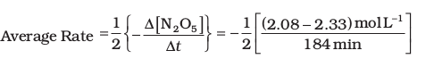  = 6.79 × 10^{–4} mol L^{–1}/min = (6.79 × 10^{–4} mol L^{–1} min^{–1}) × (60 min/1h)  = 4.07 × 10^{–2} mol L^{–1}/h  = 6.79 × 10^{–4} mol L^{–1} × 1min/60s  = 1.13 × 10^{–5} mol L^{–1}s^{–1}  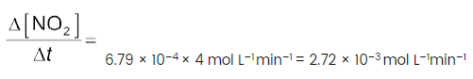 | 2+1
11 | 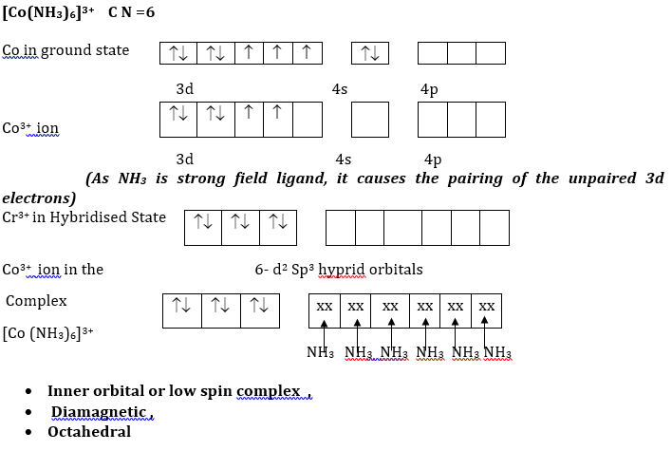 | 3
 | SECTION-D
12 | - Kohlrausch's law states that the molar conductivity of an electrolyte can be represented as the sum of the molar conductivity of its individual ions, each multiplied by its charge and concentration.  (b)  $Λ_{m}=\frac{κ×1000}{M}Λ_{m}=\frac{0.0248×1000 Scm-1}{0.20 \frac{mol}{cm3}}$=124 S Cm² mol⁻¹  (c)  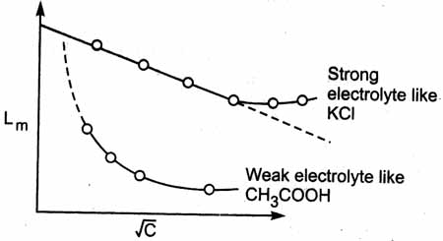  For strong electrolytes: - The graph shows that there is very small increase in molar conductivity with increase in dilution .  For weak electrolyte this increase in in Λm is very high as compared with the strong electrolytes as shown graph.  - Molar conductivity at infinite dilution for strong electrolyte can be found by extrapolation to zero concentration but that of weak electrolytes can not be thus found.  OR  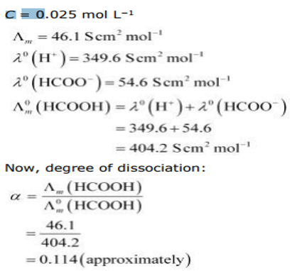 | 1+1+2
13 | (i) EDTA  (ii) Cis- Platin  (iii)In Biological systems:-Several naturally occurring biologically important compounds are coordination compounds.  Haemoglobin –is complex with porphyrin. Chlorophyll is green pigment is complex of Mg²⁺ with porphyrin , Vit-B₁₂ (Cynocobalamine)  Extraction of metals: cyanide ions are used for the for the extraction of gold and silver(by leaching). Nickel is purified by converting the metal to the gaseous compound Ni(CO)₄ and then decomposing the latter to pure nickel(Mond process)  OR  - pentaamminechloridocobalt (III) Nitrate  - potassiumhexacyanido ferrate (II). | 1  1  1  1  1+1
 | SECTION ;- E
14 | (a)(i) This is because of poor shielding by 5f electrons in actinoids in comparison with shielding of 4f electrons in lanthanoids.  (ii)Because of large number of unpaired electrons in their atoms they have stronger interatomic interaction and hence stronger bonding between atoms resulting in higher enthalpies of atomization.  (iii) d-d transition  (b) (i)  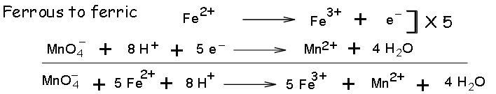  (ii)  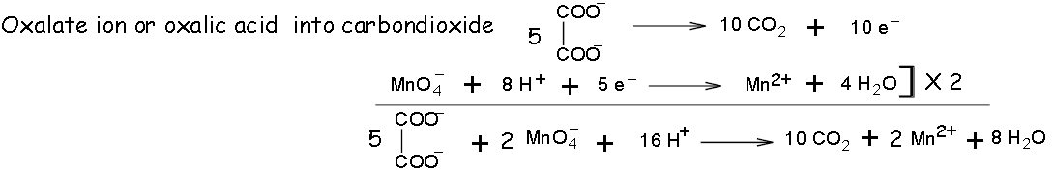  OR  (a)  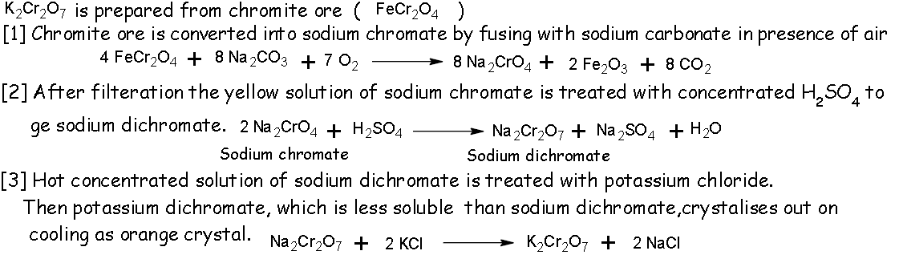  (b) (i)  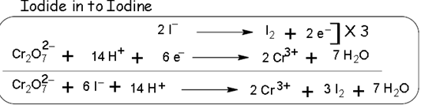  (ii)  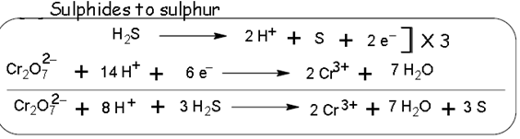 | 1+1+1+1+1  1+1+1+1+1
15 | a)Mass of HN0₃ in solution = 68 g  Molar mass of HNO₃ =63 g MOL ⁻¹  Mass of solution = 100 g  Density of solution = 1.504 g ML⁻¹  Volume of solution = $\frac{Mass of solution}{Density of solution}$  = $\frac{(100g)}{\left(1.504 g mL-1 \right)}$ = 66.5 mL = 0.665 L  Molarity of solution (M) = $\frac{Mass of HNO3/Molar mass of HNO3}{\begin{aligned}Volume of solution in Litres \\ \end{aligned}}$  = $\frac{(68g/63g mol-1)}{(0.665 L)}$ = 16.23 mol L⁻¹ = 16.23 M.  (b) (i)It shrinks in a concentrated saline solution.  (ii)Aquatic species are more comfortable in cold water due to the presence of more oxygen. Solubility of oxygen in water increases with decrease in temperature as solubility of a gas in given liquid decreases with increase in temperature.  (iii)The phenomenon involved in the process is depression in the freezing point .  OR  (a)  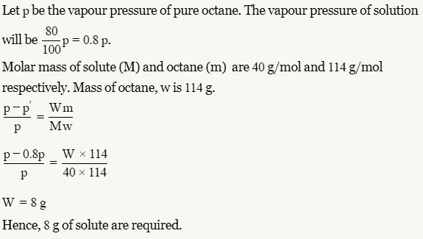  (b)(i)Non-ideal solution with negative deviation forms maximum boiling azeotrope.  (ii) This is because KCl dissociates in water to give two ions (KCI→K⁺ + Cl⁻), whereas glucose does not dissociate. Therefore, number of solute particles is greater in 0.1 M KCl as compared to 0.1 M glucose.  (iii)The pure solvent flows out of the solution through semi - permeable membrane and this phenomenon is called as reverse osmosis. | 2+1+1+1

PRACTICE PAPER BOO 1 SET 14 CLASS –XII SESSION - (2023 -24)
SUBJECT – CHEMISTRY
S NO | NAME OF CHAPTER | MCQ  (1Mark) | Assertion & reason | SA I (2 Mark) | SA TYPE-II ( 3 Mark) | Case Based  (4 Marks) | LONG ANSWER  (5MARKS) | TOTAL  marks
1 | Solutions |  |  |  | 3(1) | 4(1) |  | 7(2)
2 | Electrochemistry | 1(1) |  |  | 3(1) |  | 5(1) | 9(3)
3 | Chemical Kinetics | 3(3) |  | 4(2) |  |  |  | 7(5)
4 | d -and f -Block Elements | 1(1) | 1(1) |  |  |  | 5(1) | 7(3)
5 | Coordination Compounds | 2(2) |  | 2(1) | 3(1) |  |  | 7(4)
 |  | 7(7) | 01(1) | 06(3) | 9(3) | 4(1) | 10(2) | 37(17)

Set 14
Practice Paper BOOK 1 (2023-24)
MM:37 CHEMISTRY THEORY (043) Time: 1 ½ hours
The following questions are multiple -choice questions with one correct answer. Each question carries 1 mark. There is no internal choice in this section
- The magnetic nature of elements depends on the presence of unpaired electrons. Identify the configuration of transition elements which shows highest magnetic moment?
(a) 3d⁷ (b) 3d⁵ (c) 3d⁸ (d) 3d²

- Zinc is coated over iron to prevent rusting of iron because.
(a) it is cheaper than iron (b) E^{O}_{Zn}²⁺/Zn = E⁰ _{Fe}²⁺/Fe
(c) E^{O}_{Zn}²⁺/Zn > E⁰ _{Fe}²⁺/Fe (d) E^{O}_{Zn}²⁺/Zn < E⁰ _{Fe}²⁺/Fe

- A first order reaction is 50% completed in 1.26 × 10¹⁴s. How much time would it take for 100% completion?
(a) 1.26×10¹⁵s (b) 2.52×10¹⁴s (c ) 2.52×10²⁸s (d) Infinite

- The slope in the plot of ln[R] vs. time gives in first order reaction.
(a) +k (b) +k/2.303 (c ) –k (d)–k/2.303

- How many ions are produced from the complex [Co(NH₃)₆]Cl₂ in solution?
(a) 6 (b) 4 (c) 3 (d) 2

- For the reaction A→B , the rate of reaction becomes three times when the concentration of A is increased by nine times . What is the order of reaction?
(a) 1 (b) 2 (c) ½ (d) 0
- Amongst the following, the most stable complex is-
(a) [FeCl₆]³⁻ (b) [Fe(NH₃)₆]³⁺ (c) [Fe(C₂O₄)₃]³⁻ (d) [Fe(H₂O)₆]³⁺

In the Following questions a statement of Assertion(A) is followed by a statement of Reason(R). Select the most appropriate answer from the options given below:
(a) Both A and R are true and R is the correct explanation of A
(b) Both A and R are true but R is not the correct explanation of A.
(c) A is true but R is false.
(d) A is false but R is true.

- Assertion (A): Group 12 elements are not considered as transition metals.
Reason (R): Transition metals are those which have incompletely filled d shell in their compounds

SECTION B
This section contains 5 questions with internal choice in one question. The following questions are very short answer type and carry 2 marks each.
- A first order reaction has a rate constant 1.15×10⁻³S⁻¹.How long will 5g of this reactant take to reduce to 3g? Given: log 5=0.6989, log 3= 0.477
- A complex of the type [M(AA)₂X₂] ^{n+} is known to optically active.what does this indicate about the structure of the complex ? Give one example of such complex.
- (a) on increasing temperature, activation energy of a reaction decreases, why?
(b)In some cases, it is found that a large number of colliding molecules have energy more than threshold energy, yet the reaction is slow why?
SECTION C
This section contains 7 questions with internal choice in one question. The following questions are short answer type and carry 3 marks each.
- (a) Although both [NiCl₄]²⁻ and [Ni(CO)₄] have sp³ hybridization ,yet [NiCl₄]²⁻
is paramagnetic and [Ni(CO)₄] is diamagnetic. Give reason. (Atomic number of Ni=28)
(b)On the basis of crystal field theory, write the electronic configuration for d⁵ ion.
(i) Δ₀​>P (ii) Δ₀​<P
- Answer the following questions.
- Measurement of osmotic pressure method is preferred for the determination of molecular masses of macromolecules such as protein and polymers.
- Aquatic animals are more comfortable in the cold water than in warm water.
(c) Elevation of boiling point of 1 M KCl solution is nearly double than that of 1 M sugar solution.
- Calculate E_{cell} for the following reaction at 298 K
2Cr(s) + 3Fe²⁺ (0.01 M) → 2Cr³⁺ (0.01 M) + 3Fe(s) Given: Eº_{cell} = 0.261 V
SECTION D
The following questions are case -based questions. Each question has an internal choice and carries 4 (1+1+2) marks each. Read the passage carefully and answer the questions that follow.
- Read the passage given below and answer the following questions:
Boiling point or freezing point of liquid solution would be affected by the dissolved solids in the liquid phase. A soluble solid in solution has the effect of raising its boiling point and depressing its freezing point. The addition of non-volatile substances to a solvent decreases the vapor pressure and the added solute particles affect the formation of pure solvent crystals. According to many researches the decrease in freezing point directly correlated to the concentration of solutes dissolved in the solvent. This phenomenon is expressed as freezing point depression and it is useful for several applications such as freeze concentration of liquid food and to find the molar mass of an unknown solute in the solution. Freeze concentration is a high quality liquid food concentration method where water is removed by forming ice crystals. This is done by cooling the liquid food below the freezing point of the solution. The freezing point depression is referred as a colligative property and it is proportional to the molar concentration of the solution (m), along with vapor pressure lowering, boiling point elevation, and osmotic pressure.
Give reasons of following
- Cooking is faster in pressure cooker than in cooking pan.
- Red blood cells(RBC) shrink when placed in saline waterbut swell in distilled water.
- A decrease in temperature is observed on mixing ethanol and acetone.
OR
(c) Potassium chloride solution freezes at a lower temperature than water.
SECTION E
The following questions are long answer type and carry 5 marks each.
All questions have an internal choice.
- Attempt any five of the following:
(a) Transition metal form complex compounds.
(b) Actinoids show wide range of oxidation states.
(c) Eº value for (Zn²⁺/Zn) is negative while that of (Cu²⁺/Cu) is positive.
(d)Sc³⁺ is colourless in an aqueous solution whereas Ti³⁺ is coloured.
(e) Complete and balance the following chemical equations.
Fe²⁺ + MnO₄⁻+ H⁺
(f) The transition metals are generally paramagnetic in nature why?
(g) Complete and balance the following chemical equations

MnO₄⁻ + 4 H⁺ + 3e
- (a) The conductivity of 0.001 M acetic acid is 4 x 10⁻⁵ S/m. Calculate the dissociation constant of acetic acid if λ⁰m for acetic acid is 390 S cm² mol⁻¹.
(b)Write Nernst equation for the reaction at 25°C :
2 Al (s) + 3 Cu²⁺ (aq) —-> 2 Al³⁺ (aq) + 3 Cu (s)​
(c ) What are Secondary Batteries ? Give an example.
OR
- Following reaction takes place in the cell:
Zn (s) + Ag₂O (s) + H₂O (l) → Zn²⁺ (aq) + 2Ag (s) + 20H– (aq)
Calculate Δ_{r}G° of the reaction.[Given: E°_{(Zn}²⁺/Zn) = – 0.76 V,
E°_{(Ag}²⁺/Ag) = 0.80 V, 1 F = 96,500 C mol⁻¹]

- How can you determine limiting molar conductivity (∧_{m}°,) for strong electrolyte and weak electrolyte?
- How much electricity in terms of Faraday is required to produce20⋅0 g of Ca from molten CaCl₂?

*****************************************************************************************************

PRACTICE PAPER BOOK 1 SET 14
Class: XII SUBJECT: CHEMISTRY
Q.N. | 1 | 2 | 3 | 4 | 5 | 6 | 7 | 8
ANS- | b | d | d | c | c | c | c | a
- k= $\frac{2.303}{t}$log$\frac{Ro}{R} Ro$ where:[ R₀]=5g; [R[ =3g; k=1.15×10⁻³ 1.15×10⁻³= $\frac{2.303}{t}$ log $\frac{5}{3}$
And:log 5=0.6989 log 3=0.477
t=2.3031.15×10−3×(log 5−log3)=2.3031.15×10⁻³×0.2219=0.44×10³ seconds 2
- A Complex of the type [M(AA)₂X₂]n⁺ indicate cis- octahedral structure. 1
Example-cis-[Pt(en)₂Cl₂]²⁺ or any example. 1
- (a) Temperature and activation energy are inversely proportional to each other 1
(b) it is due to improper orientation 1
Two factors for a reaction 1.threshold energy 2. Proper oreantaion
- (a) Due to unapired electron(Cl is weak field ligand, CO is strong field ligand ) 1
(b) (i) t₂g⁵ (ii) t₂g³,eg² 1+1
- (a) Osmotic pressure is measured at room temp and instead of molality,molarity of the solution is used,protein and polymers are not stable at high temperature. 1
- Oxygen is more soluble in cold water 1
- Due to dissociation of KCl,i is nearly equal to 2. 1

- 3
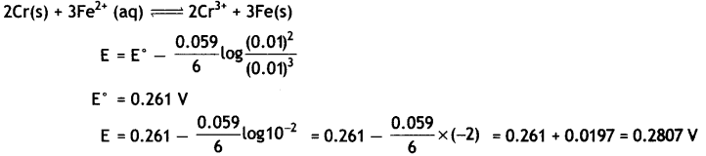
- (a) Due to increase of pressure in cooker, boiling point of water increases 1
(b) RBC looses water in saline water and absorb water in distilled water due to osmosis 1
(c ) Ethanol –acetone interaction is weaker than pure ethanol or acetone interaction. 2
OR
(c) On adding KCl, vapour pressure of the solution decreases. 2
- (a) Due to small size, high ionic charge and availability of d-orbital. (Each 1 mark)
(b) Due to very small energy gap between 5f,6d and 7s-subshell resulting in easier excitation of the outermost electrons to higher energy level.
(c)Because of stable 3d¹⁰ configuration of Zn⁺² whereas due to low hydration enthalpy and high enthalpy of atomization of Cu^{+2.}
(d) The absence of unpaired d-electron in Sc³⁺ whereas in Ti³⁺ there is one unpaired electron or Ti³⁺ shows the d-d transition.
(e) 5 Fe⁺² + MnO₄⁻ + 8 H⁺ Mn⁺² + 4 H₂O + 5 Fe⁺³
(f) due to incomplete d orbitals and presence of unpaired electron.
(g) MnO₄⁻ + 4 H⁺+3e⁻ MnO₂+ 2 H₂O
- (a) 3
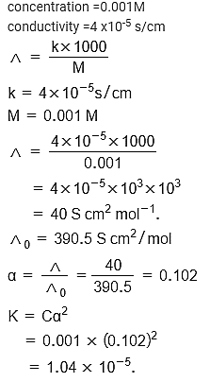
- 1
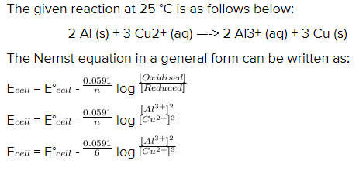
- Batteries which are rechargeable eg. Lead storage, Ni-Cd (or any) 1
OR
(a) E°_{cell} = E°_{(Ag}²⁺/Ag) – E°_{(Zn}²⁺/Zn) 2
= 0.80 – (-0.76) = 1.56V
ΔG° = -nFE°_{cell} (Here n = 2)
= – 2 × 96500 × 1.56
= – 301080 J mol⁻¹
or = – 301.080 kJ mol⁻¹
(b) For strong electrolytes ∧_{m}° can be obtained as intercept from the plot of 2
∧_{m} vs C^{-1/2} graph. For weak electrolytes ∧_{m}° can be obtained from Kohlrausch law.
(c) (b) ${Ca}^{2+}+ {2e}^{-} →Ca$ To produce 40 g Ca, electricity needed = 2F
∴ To produce 20 g Ca, electricity needed = 40/ 2 × 20 = 1F

